## RICH CARD

**We’re excited to connect with you**

BMW is more than a car brand. It’s a commitment to today’s world and tomorrow’s possibilities, respecting the environment we share and honoring the people who craft our ultimate driving machines. BMW embodies vision, creativity, and the joy of innovation. It carries a rich history and fuels the promise of the future. We invite you to truly get to know us. Welcome to BMW.

OPTION: CIRCULAR WORLD

OPTION: DIGITAL JOURNEY

OPTION: ELECTRIC FUTURE

OPTION: FREUD

OPTION: QUIZ

—-------------------------------------------------------FIM —-------------------------------------------------------

## CIRCULAR WORLD

## 

RICH CARD

We believe the ultimate driving experience happens in a bond between driver and car, but there is also a third part of this equation: the road. You deserve to see the paths carved everywhere around the world through the best possible light. There are many variables that affect this experience, that's why BMW works to protect the environment that hosts the landscapes you watch through your window.

The work of today is the energy of tomorrow, and that energy will power us through roads of a cleaner world.

## 

[*https://www.bmwgroup.com/en/sustainability.html#carousel-0b00b3d9e1-item-0cc2d5b7fd-tabpanel*](https://www.bmwgroup.com/en/sustainability.html#carousel-0b00b3d9e1-item-0cc2d5b7fd-tabpanel) *reference link*

As you explore our initiatives, you’ll notice references to several of the 17 Sustainable Development Goals (SDGs) outlined in the UN’s Agenda 2030. This global action plan guides us toward a more livable future, and at BMW, we are committed to making a meaningful impact in achieving these goals.

OPTION 1: “What we aim”

OPTION 2: “What already impacts the present”

CAROUSEL

********************************CARD 1******************************

OPTION 1: “What we aim”

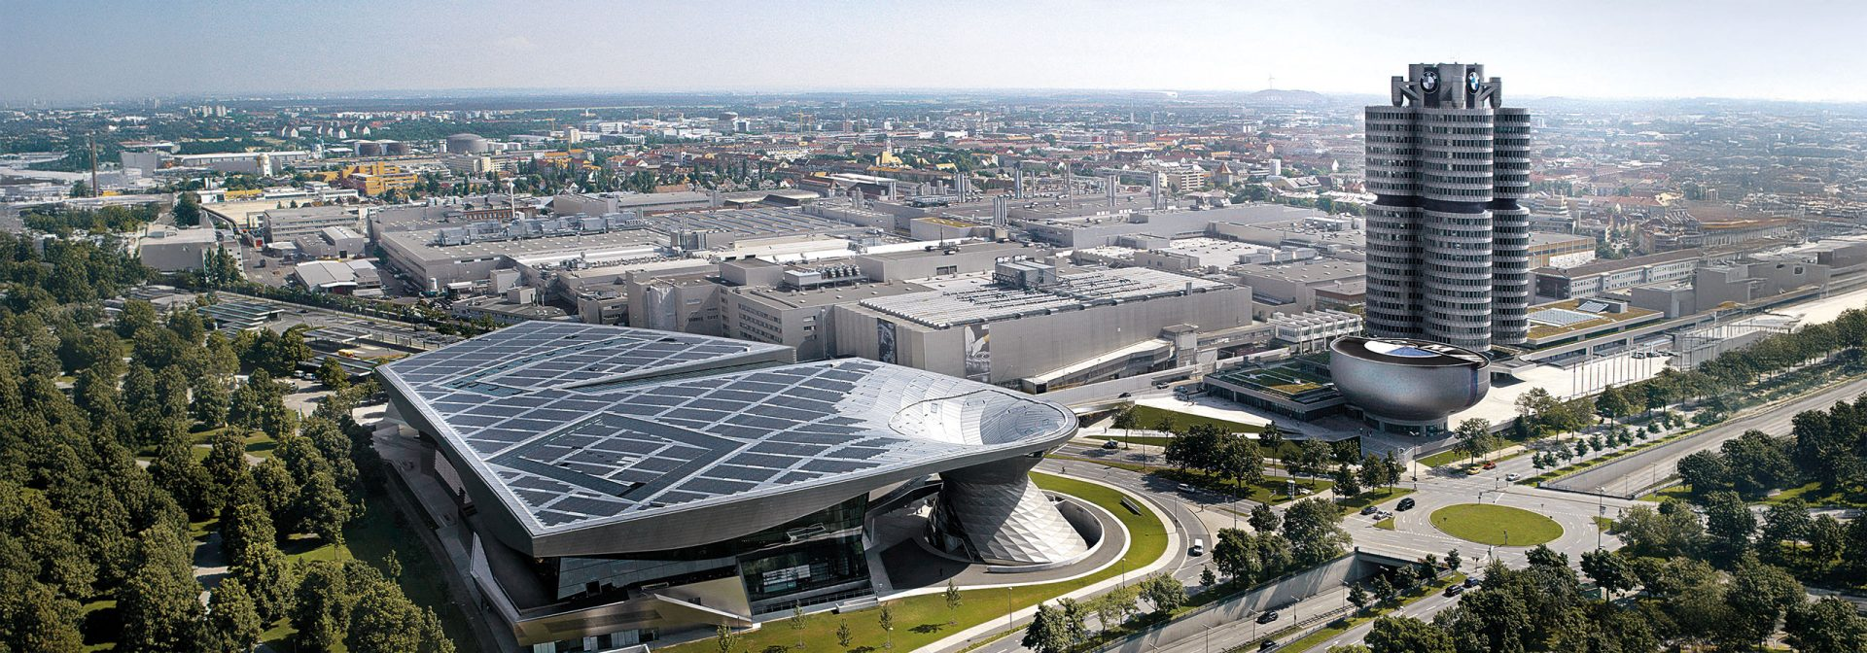

BMW aims to establish a circular economy that enables high-quality recycling. We continuously look for and implement ways to improve our recycling processes, no matter how small, because every possibility can make a difference.

[*https://www.bmwgroup.com/en/sustainability.html#carousel-f9cdf9ea9e-item-9e54d5aadd-tabpanel*](https://www.bmwgroup.com/en/sustainability.html#carousel-f9cdf9ea9e-item-9e54d5aadd-tabpanel) *(reference link is always positioned before the information that came from it)*

We are fully committed to the Paris Climate Agreement and achieving net-zero emissions by 2050. To get there, we’ve set ambitious, science-based targets to cut CO₂e emissions by at least 40 million tonnes by 2030 compared to 2019.

[*https://www.bmwgroup.com/en/sustainability/co2-reduction.html*](https://www.bmwgroup.com/en/sustainability/co2-reduction.html) *(reference link is always positioned before the information that came from it)*

Our efforts include ramping up sales of fully electric vehicles, which rose from 215,752 in 2022 to 426,594 in 2024. We expect at least 50% of global sales to be fully electric by 2030, putting about 10 million electric BMWs on the road.

********************************CARD 2******************************

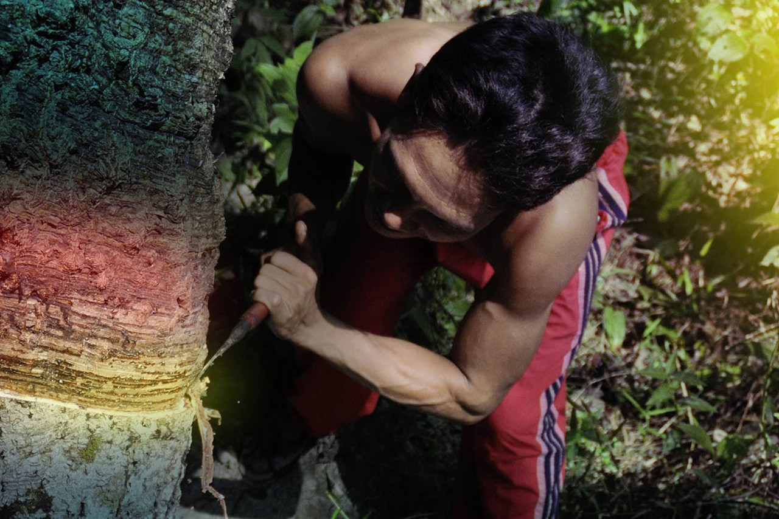Every journey on the road is shaped by countless people, and their rights also deserve protection. That’s why BMW is committed to safeguarding human rights throughout the entire supply chain, long before materials arrive at our factories. This is how we take responsibility at every step to build a truly circular world. Discover more about our efforts in these countries:

OPTION 4 “CONGO”

OPTION 5 “CHILE”

OPTION 6 “INDONESIA”

OPTION 7 “INDIA”

********************************CARD 3******************************

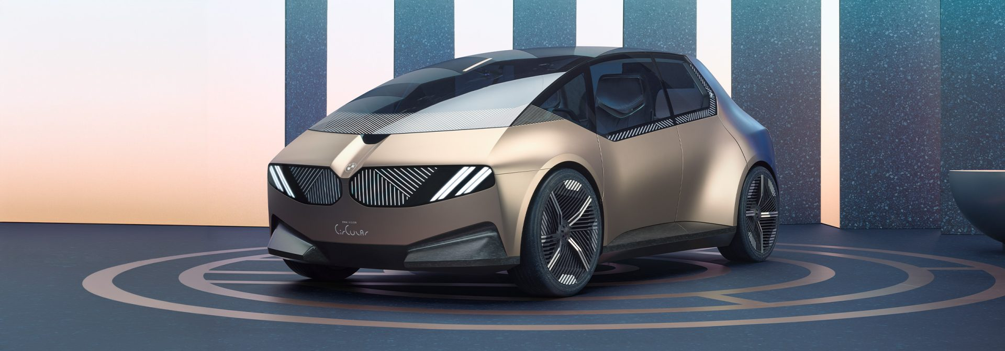While taking responsibility for our raw material supply, we also continuously elevate the use of secondary materials to power sustainable progress.

OPTION 3 - “Our responsibility towards raw materials"

OPTION 8: CIRCULAR ECONOMY - “Secondary materials become the protagonist”

—----------------------------FIM OPTION 1 “What we aim” —------------------------------

CAROUSEL

********************************CARD 1******************************

OPTION 2: “What already impacts the present”

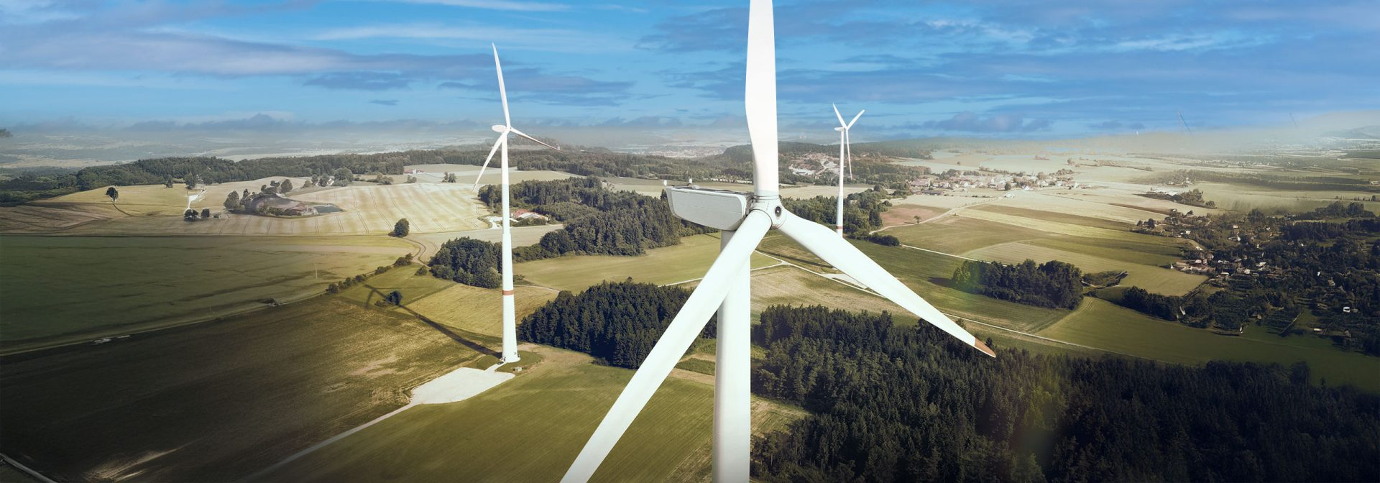All energy used in BMW Group production comes from renewable sources, and we are increasing direct purchases from specific renewable plants through Power Purchase Agreements. By combining circularity, electrification, and renewable energy, BMW Group is advancing toward a more sustainable, low-carbon future.

********************************CARD 2******************************

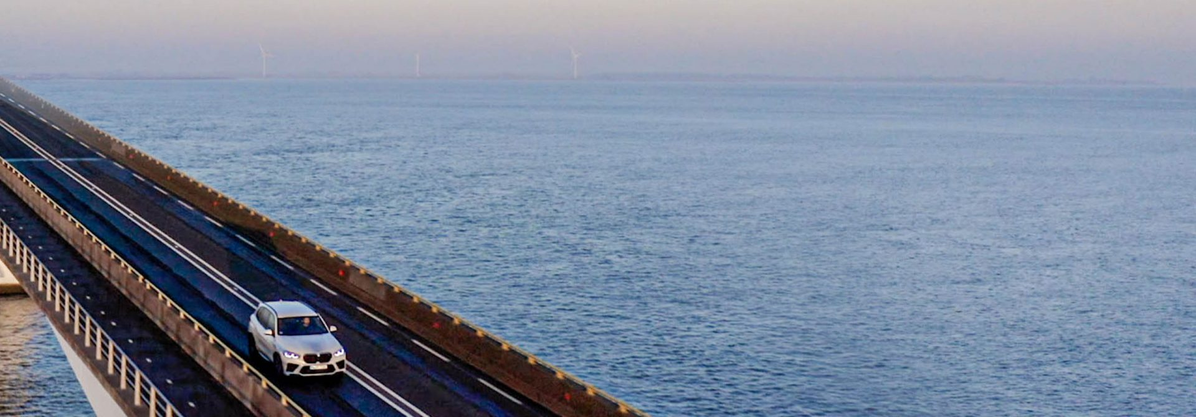We're increasing the number of **emission-free kilometers** driven by expanding **eDrive Zones**. We're also reducing fuel consumption and extending vehicle range through our **Efficient Dynamics** innovations. Importantly, we remain **open to all technologies** in our pursuit of sustainable mobility. The BMW Group continues to aggressively advance its fleet electrification. In **2024**, our sales of **electrified vehicles reached 593,215 units**, making up **24.2% of our total sales**. Of those, **fully electric vehicles accounted for 17.4%** of our total sales.

In **2025**, the BMW Group expects to offer **fully electric cars in almost every key market segment**, with **more than 15 all-electric models** across our various brands available.

********************************CARD 3******************************

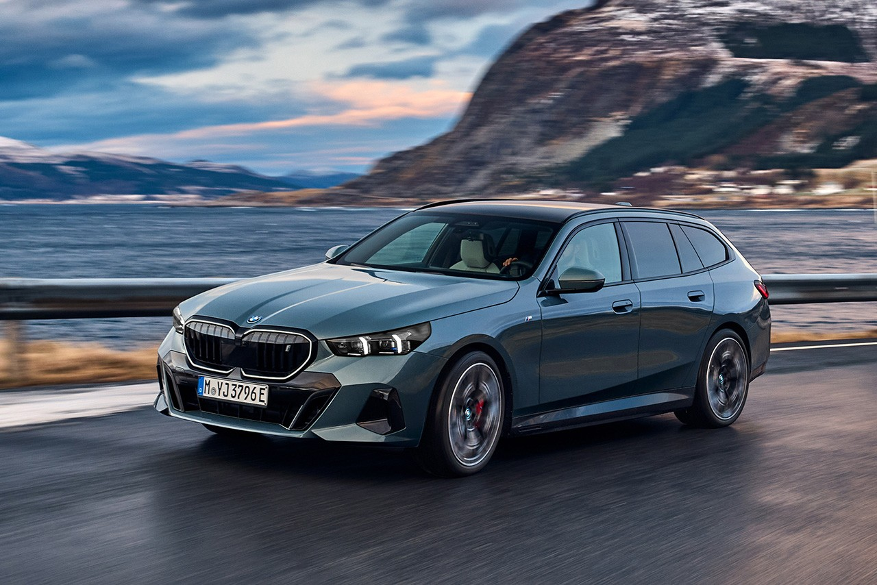

We take responsibility for the chain that supplies us with raw materials, continuously advancing the use of secondary materials to drive sustainable progress. Learn more about it:

OPTION 3 - “Our responsibility towards raw materials" OU “Secondary materials become the protagonist: OPTION 8: CIRCULAR ECONOMY

********************************CARD 4******************************

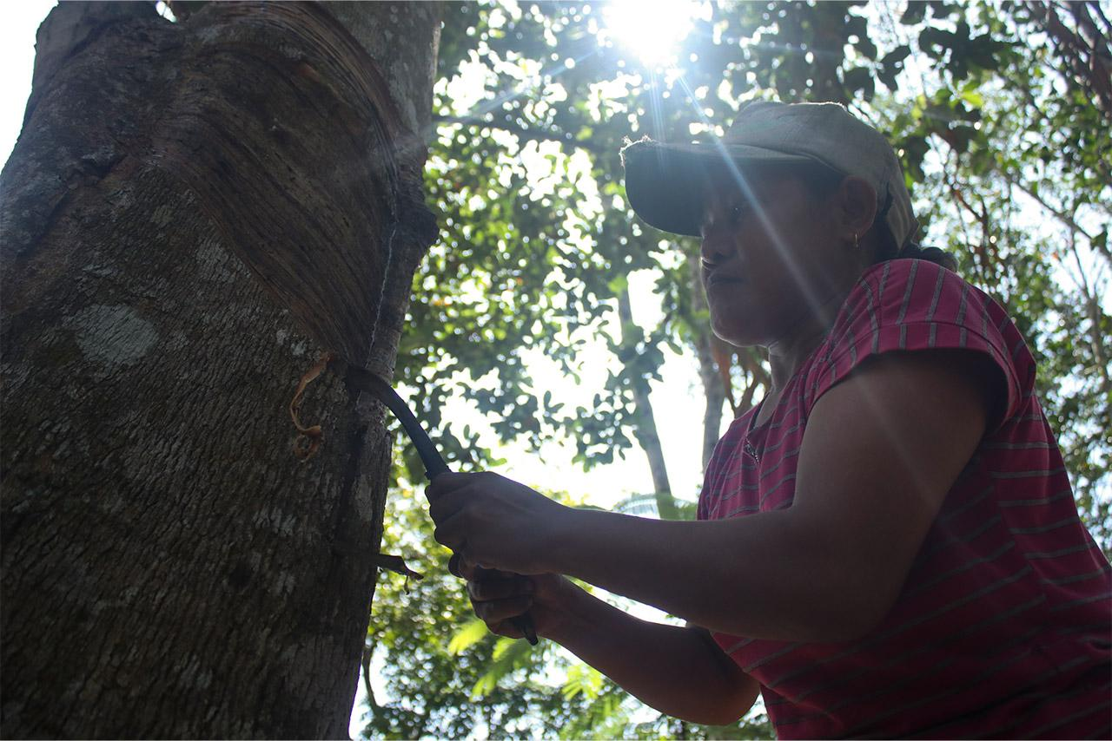Behind every road trip are many hands and lives that must be respected and protected. BMW ensures human rights are upheld across our supply chain, starting well before production begins. This holistic approach drives our mission to create a sustainable, circular future. Explore our work in these countries:

OPTION 4 “CONGO”

OPTION 5 “CHILE”

OPTION 6 “INDONESIA”

OPTION 7 “INDIA”

---------------------FIM OPTION 2 - “What already impacts the present”------------------

*(https://www.bmwgroup.com/en/sustainability/responsible-raw-material-management.html#carousel-35691fdd3c-item-ebcfff2228-tabpanel)reference link*

OPTION 3 - “Our responsibility towards raw materials"

CAROUSEL

********************************CARD 1******************************

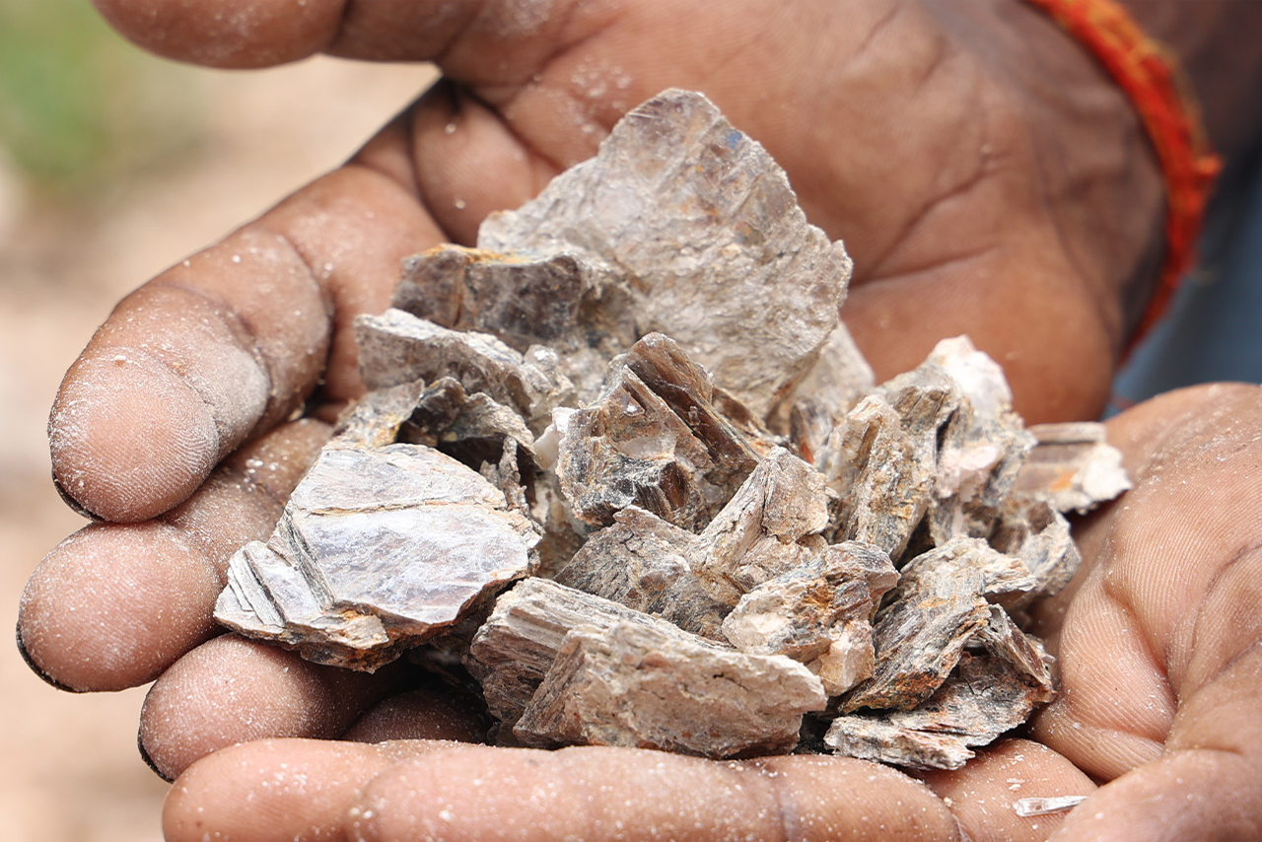Raw material extraction affects workers throughout the entire supply chain, not just those closest to the BMW Group. We are committed to caring for both the materials in our vehicles and the people who extract them, recognizing that ethical responsibility goes beyond supply: it’s about people.

BMW Group participates in multiple initiatives to promote responsible raw material management and ensures environmental and social compliance through a rigorous, multi-stage due diligence process.

Learn about our initiatives: open in webview

[Initiative for Responsible Mining Assurance (IRMA)](https://responsiblemining.net/)

[Responsible Minerals Initiative (RMI)](https://www.responsiblemineralsinitiative.org/)

[Towards Sustainable Mining Initiative (TSM)](https://mining.ca/towards-sustainable-mining/)

[Drive Sustainability](https://www.drivesustainability.org/)

[Consolidated Mining Standards Initiative](https://miningstandardinitiative.org/)

********************************CARD 2******************************

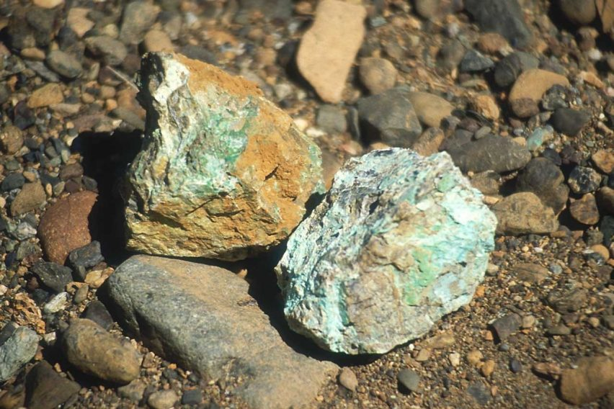

The BMW Group actively supports the **responsible sourcing of raw materials** for its production, and also engages in **field projects** with partners and local stakeholders for specific materials, adhering to the principle of **empowerment before withdrawal**. Currently, these projects focus on materials such as **cobalt, lithium, mica, and natural rubber**.

[*https://www.bmw.com/en/circular-world.html*](https://www.bmw.com/en/circular-world.html) *reference link*

********************************CARD 3******************************

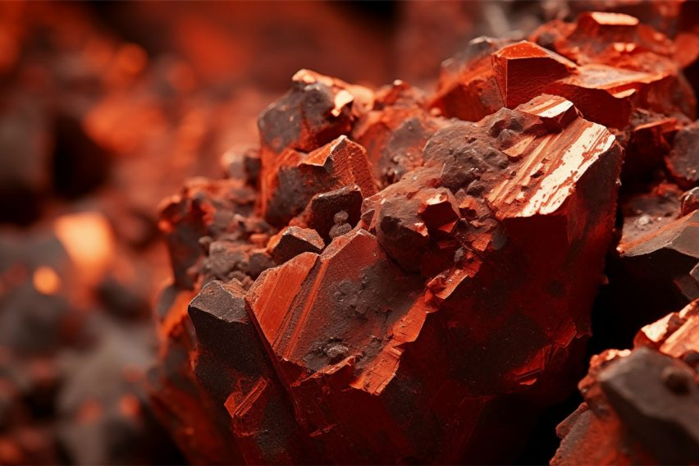

As we said, many people impact your journey on the roads, and they must be protected. That's why BMW works on taking care of the human rights in the supply chain, even before they reach our factories. That's how BMW works on each point necessary for building a circular world. Learn about our work in:

OPTION 4 “CONGO”

OPTION 5 “CHILE”

OPTION 6 “INDONESIA”

OPTION 7 “INDIA”

—--FIM OPTION 2 -OPTION 3 - “Our responsibility towards raw materials" ----------

OPTION 4 “CONGO”

CAROUSEL

********************************CARD 1******************************

[*https://www.bmwgroup.com/en/sustainability/responsible-raw-material-management.html#accordion-54c4af1cb3-item-3c4acf7a9b*](https://www.bmwgroup.com/en/sustainability/responsible-raw-material-management.html#accordion-54c4af1cb3-item-3c4acf7a9b) *reference link*

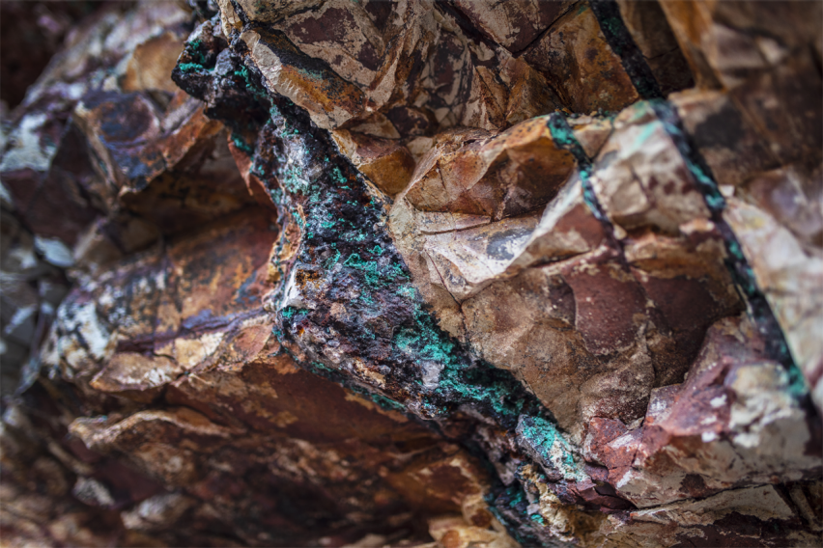

The "Cobalt for Development (C4D)" project is an initiative that aims to formalize artisanal and small-scale cobalt mining (ASM) in the Democratic Republic of the Congo, specifically in the Kolwezi region of Lualaba Province.

The Democratic Republic of Congo holds the world’s largest cobalt reserves and leads global production. Approximately 20% of its cobalt is extracted through artisanal and small-scale mining (ASM), which, despite its inherent risks, remains a vital source of income for the region. Over one million people depend on ASM, making it one of the region’s most significant livelihoods.

********************************CARD 2******************************

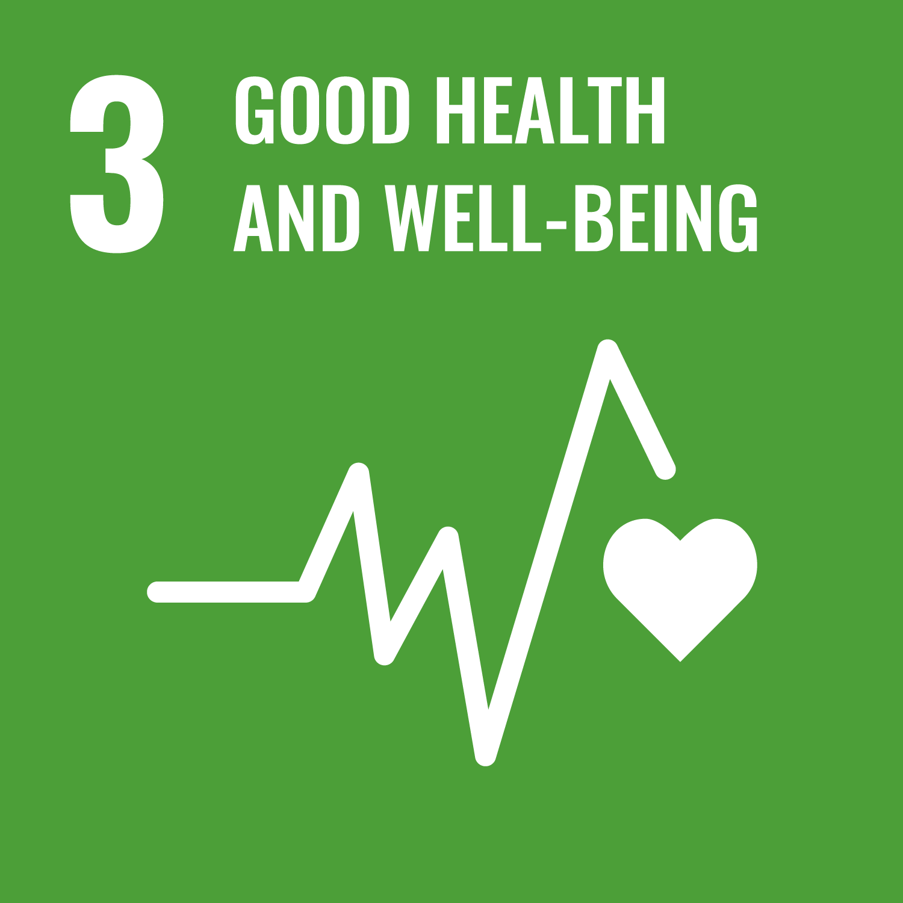

**Training and Awareness** Artisanal miners often work without adequate protective equipment, facing daily risks such as mine collapses, landslides, toxic dust exposure, and frequent accidents.  
 *To address this, C4D develops targeted training and awareness programs to improve occupational health and safety, and promotes better environmental management at mine sites.*

********************************CARD 3******************************

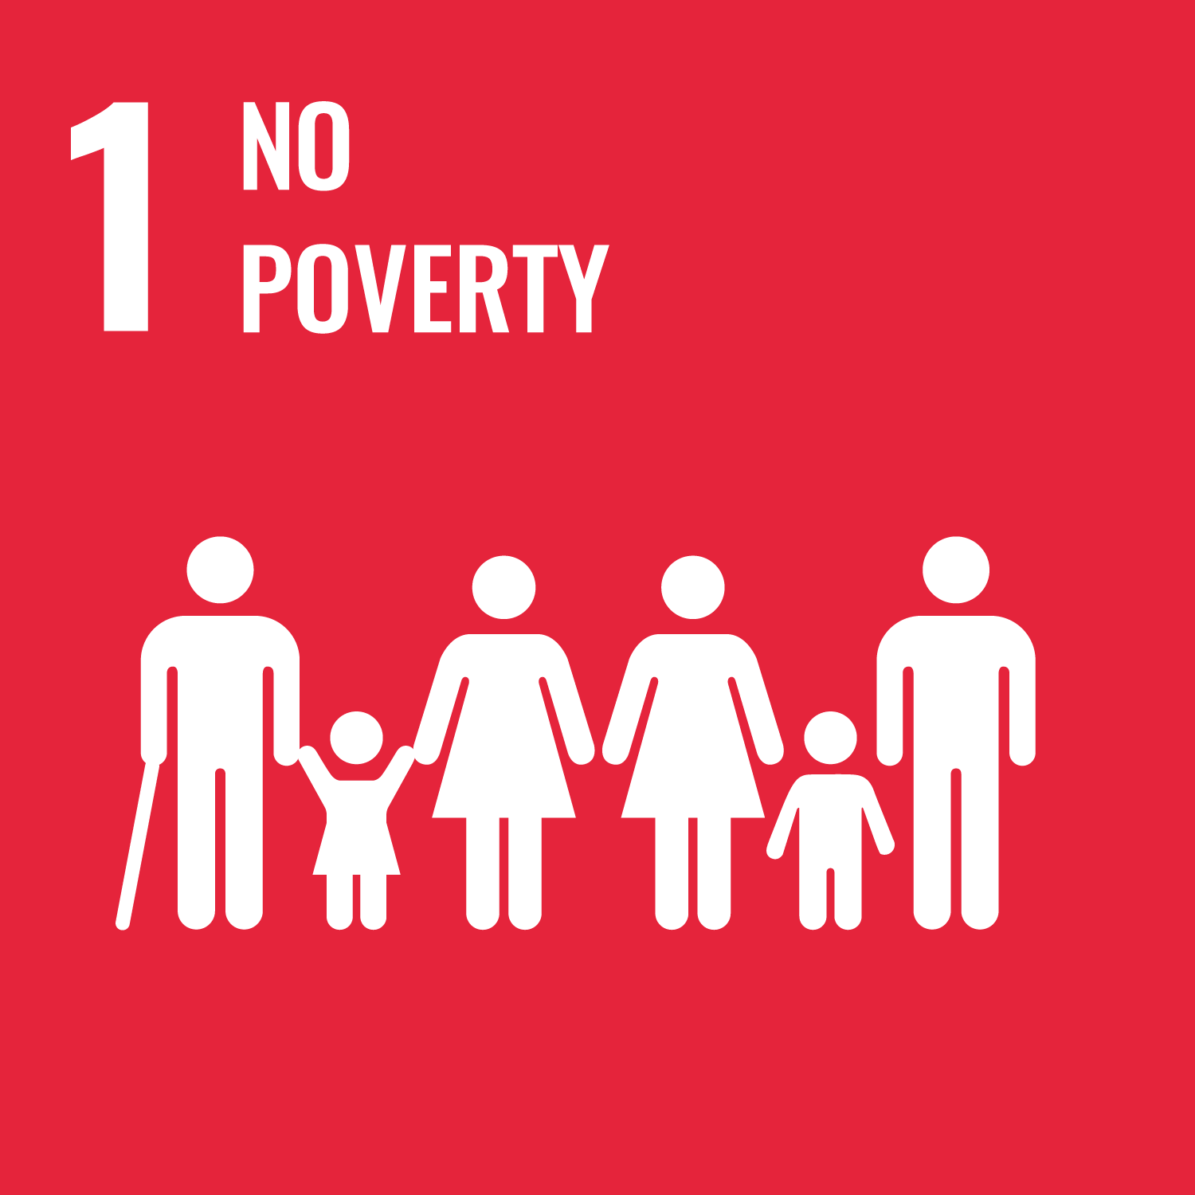

**Access to education and Alternative Livelihoods** In Lualaba Province, widespread poverty means many rely on artisanal mining as their main, though precarious, source of income. The absence of viable alternatives deepens dependence on mining and limits household savings.  
 *C4D supports access to education and the development of alternative livelihoods, such as farming and small businesses, empowering families to diversify their income and strengthen financial resilience.*  Although primary schooling is officially free, costs for books and uniforms often prevent attendance. Many children leave school early to support their families, fueling child labor in mines.  
 *C4D promotes education by supporting school construction, teacher training, and initiatives that help children stay in school, reducing reliance on child labor.*

********************************CARD 4******************************

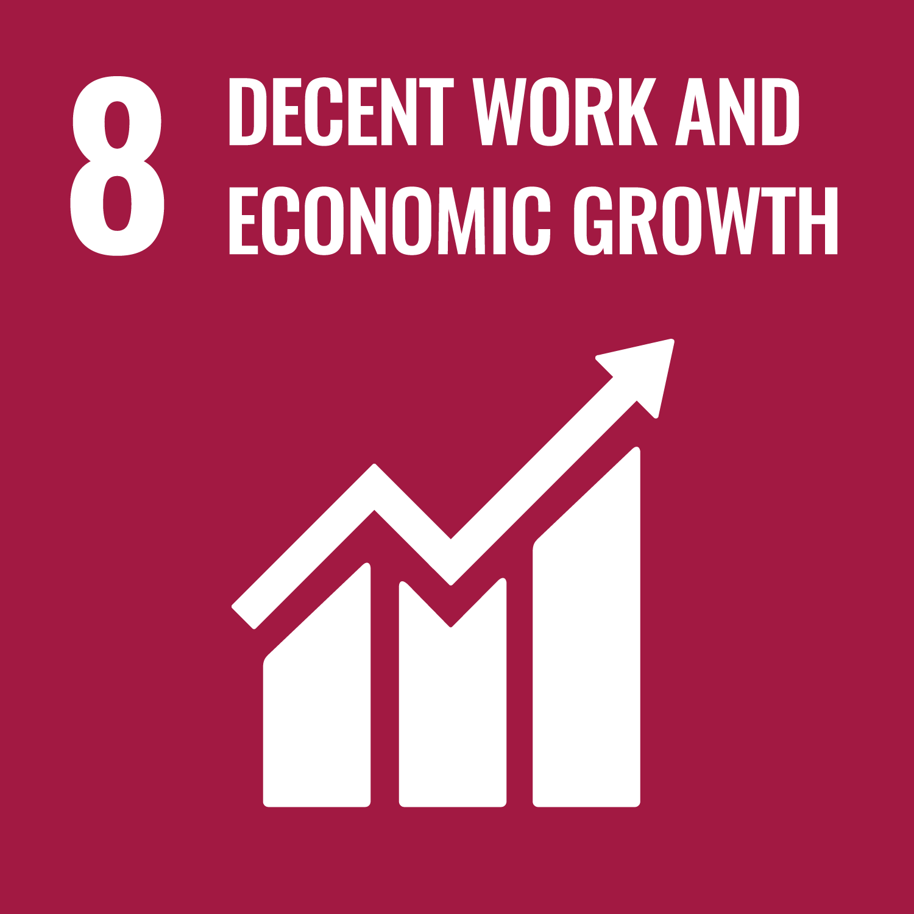

**Improve living conditions**

The influx of miners and mining-related activities can create social challenges, including increased substance abuse, prostitution, and community conflict.  
 *C4D works to improve overall living conditions for ASM workers and their communities, fostering social cohesion and well-being.*

********************************CARD 5******************************

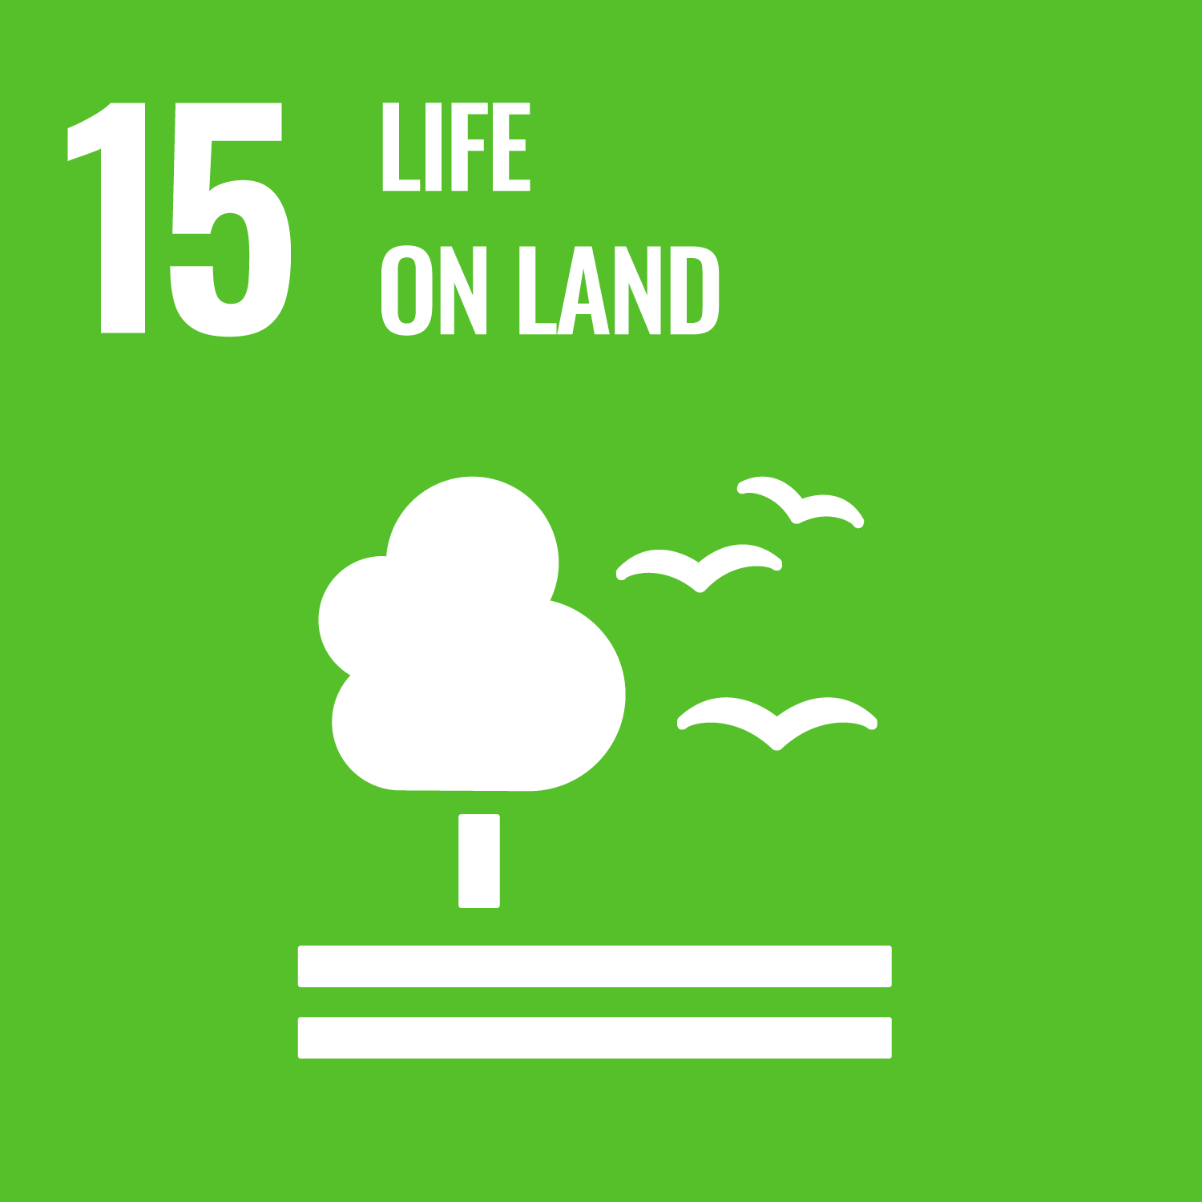

**Environmental Awareness** Mining activities frequently lead to pollution of water, soil, and air, with improper waste disposal and lack of environmental management harming local communities.  
 *C4D raises awareness of environmental risks and introduces better environmental management practices to reduce the sector’s ecological footprint.*

********************************CARD 6******************************

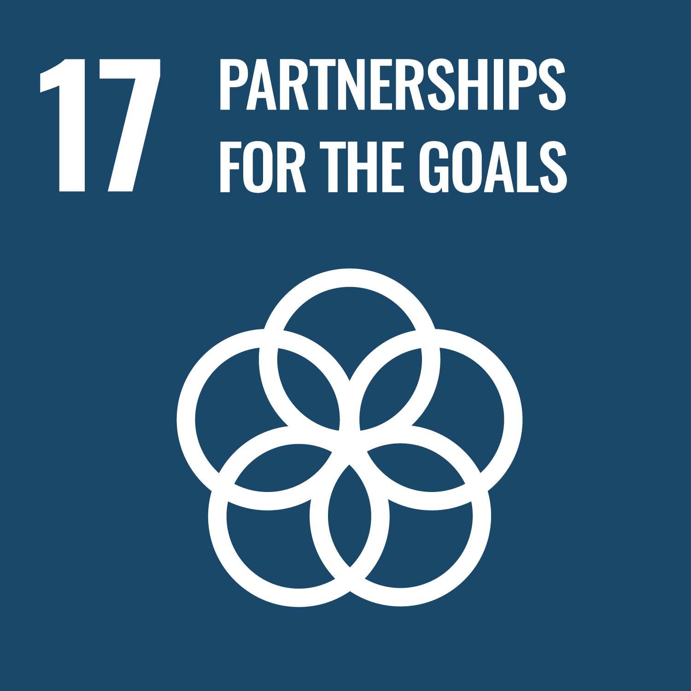

**Strengthen legal compliance** A significant share of cobalt comes from the informal ASM sector, where weak regulation and oversight make it difficult to ensure compliance with labor, environmental, and human rights standards. *C4D collaborates with mining cooperatives, local authorities, and civil society to strengthen legal compliance, improve management systems, and promote transparency across the supply chain.*

********************************CARD 7******************************

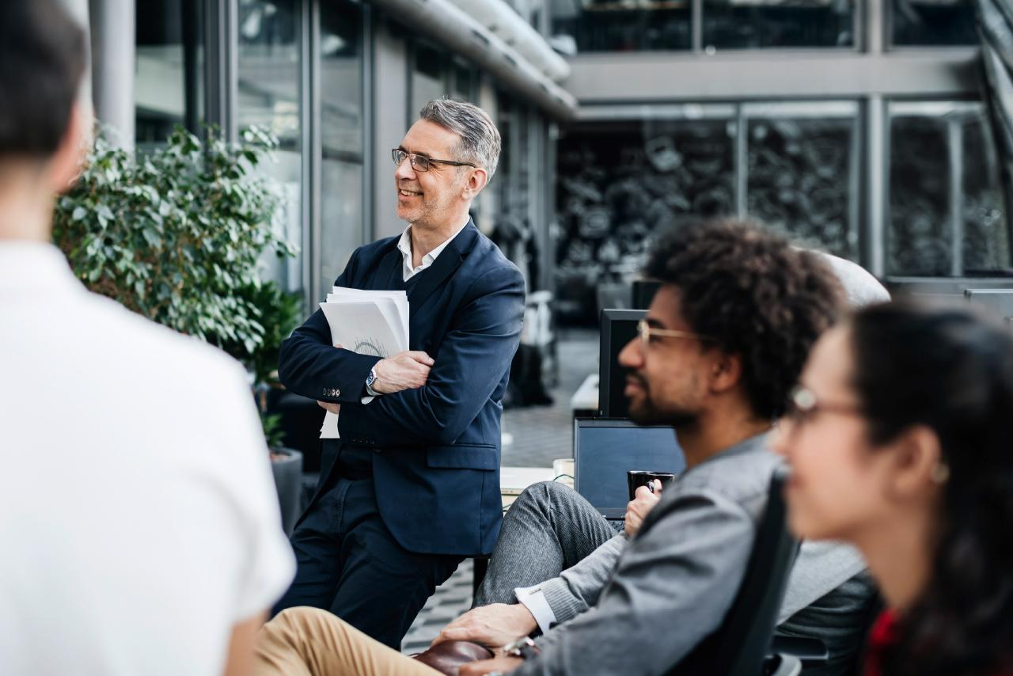

Just as we care deeply for the people and processes throughout our supply chain, we know that BMW thrives because of the dedicated individuals who bring our vision to life. Also, our commitment to a better world doesn’t stop at responsibly sourcing raw materials, it extends to how we handle secondary materials as well. By continuing our efforts beyond the initial supply chain, we ensure that our planet remains at the heart of everything we do.

We nurture from within: OPTION 9: Employees.

Secondary materials become the protagonist: OPTION 8: CIRCULAR ECONOMY

—--------------------------FIM OPTION 4 “CONGO”-----------------------------------------

OPTION 5 “CHILE”

CAROUSEL

********************************CARD 1******************************

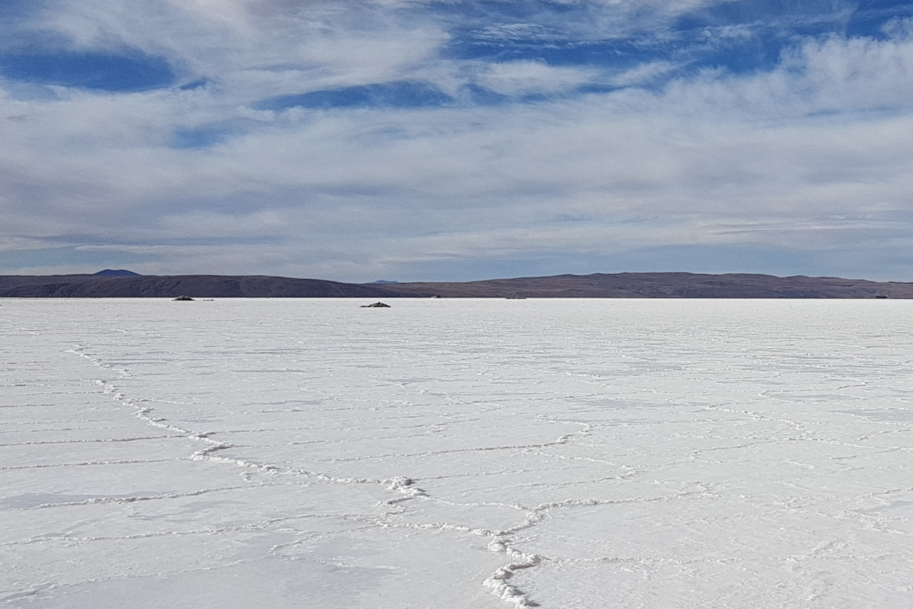The Responsible Lithium Partnership, supported by BMW Group, is a multi-stakeholder initiative promoting sustainable lithium extraction in Chile’s Salar de Atacama. This region, part of the Lithium Triangle, holds vast lithium reserves but faces environmental risks, especially to local water sources and fragile ecosystems, due to extraction methods.

Lithium is crucial for batteries, but protecting drinking water and the environment is equally important. The initiative focuses on sustainable mining practices, open dialogue, and cooperation among local communities, indigenous groups, and mining companies to balance resource needs with ecosystem and community protection.

********************************CARD 2******************************



**Collaborative Engagement** This initiative unites a diverse group of stakeholders, including the BMW Group, leading automotive companies such as Mercedes-Benz Group, Daimler Truck AG, and Volkswagen Group, as well as BASF SE and technology company Fairphone. Together, we are committed to advancing sustainable lithium mining practices.

**Multi-Stakeholder Platform: Mesa Multiactor** Coordinated by the Deutsche Gesellschaft für Internationale Zusammenarbeit (GIZ), the project has established the “Mesa Multiactor”, a multi-stakeholder platform that brings together around 20 organizations. This includes representatives from indigenous communities, civil society, academia, and both public and private sectors. Their shared mission: to build a common understanding of current conditions and to shape a sustainable vision for the future of the Salar de Atacama watershed.

********************************CARD 3******************************

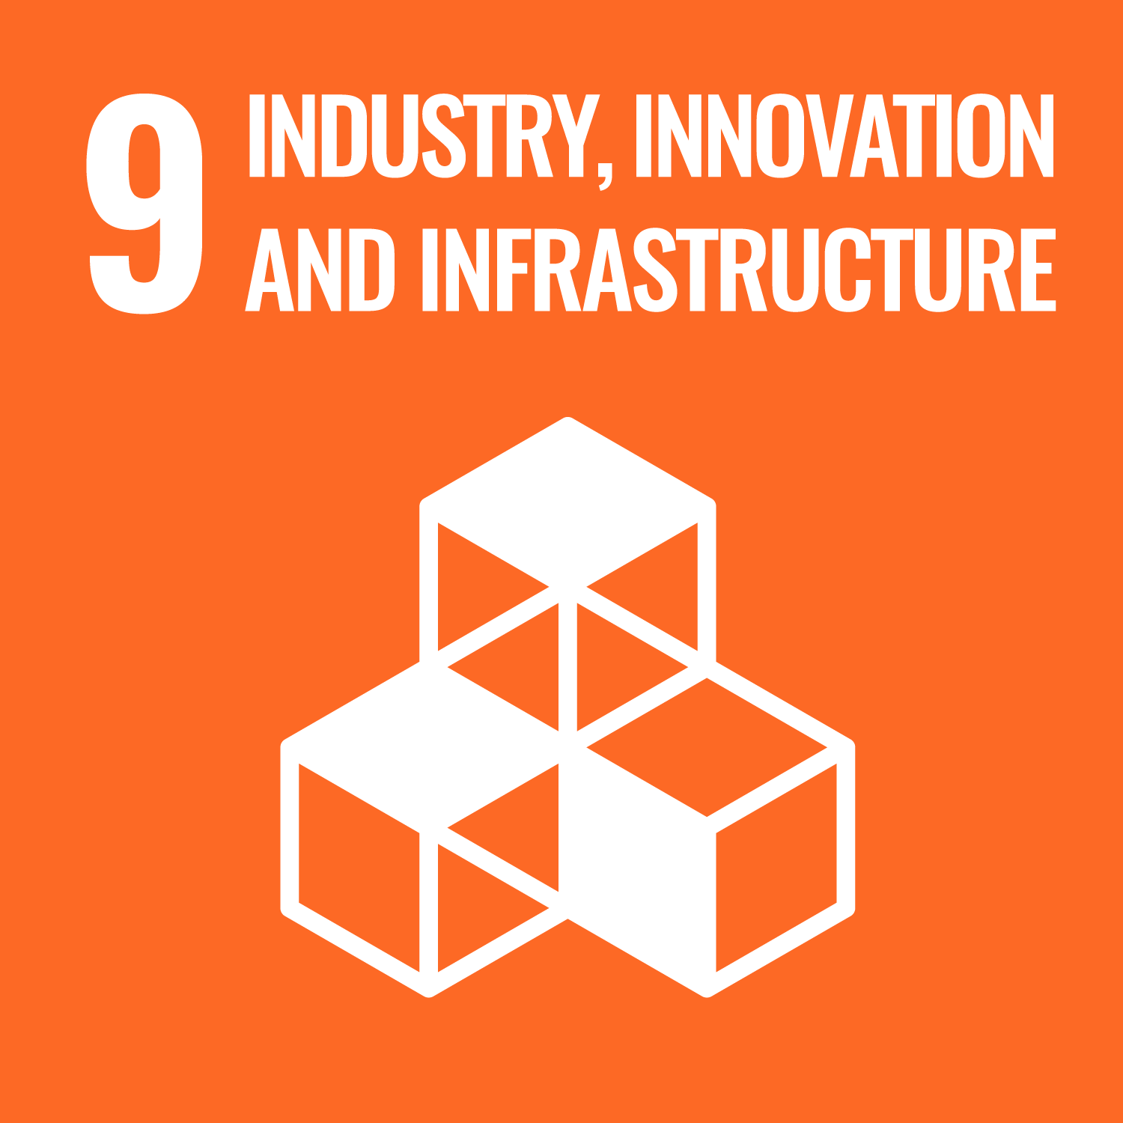

**Dialogue Driven by Science** The partnership centers on fostering open dialogue among local stakeholders, grounded in scientific evidence. By deepening our understanding of the complex relationship between freshwater and lithium brine layers, we can better evaluate technologies and strengthen expertise for responsible resource management.

********************************CARD 4******************************

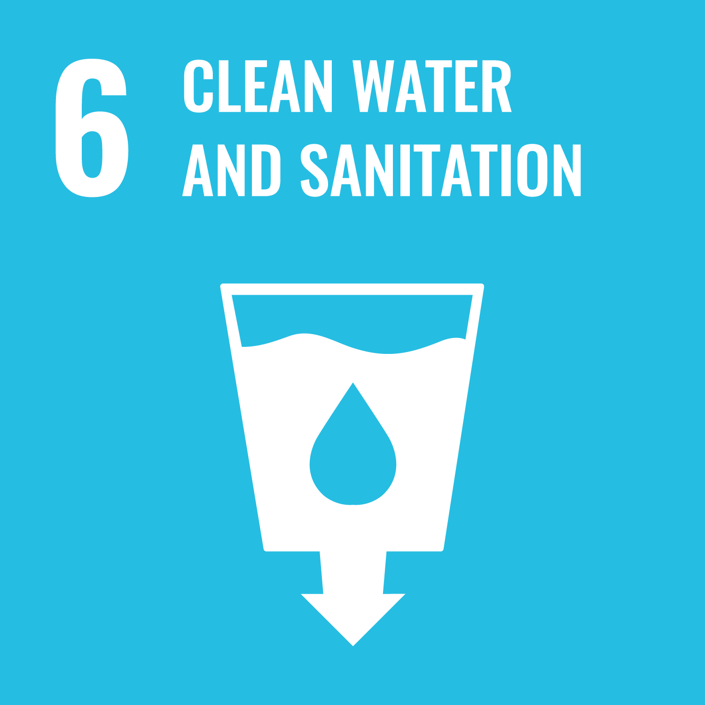

**Addressing Environmental and Social Risks** The partnership is dedicated to identifying and mitigating environmental and social risks linked to lithium mining, with a particular focus on water management and its impact on local ecosystems and communities.

********************************CARD 5******************************

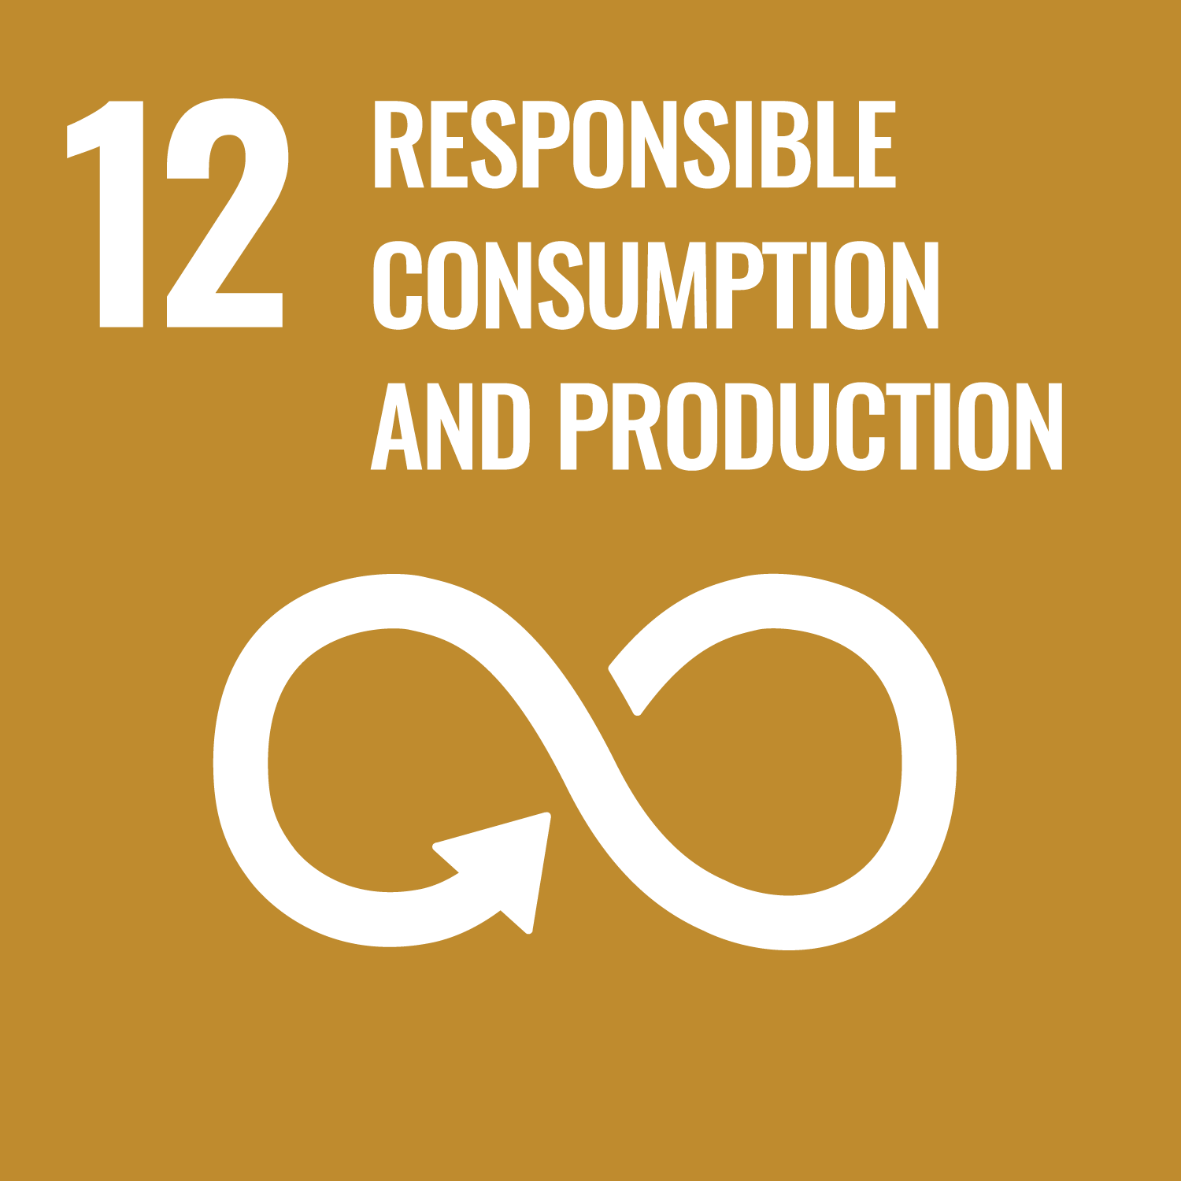

**Joint Action Plan** Members of the Mesa Multiactor have developed a Joint Action Plan aimed at improving the long-term stewardship of natural resources and implementing concrete initial measures.

********************************CARD 6******************************



**Sole Focus on Sustainability** It is important to note that the Responsible Lithium Partnership is not involved in lithium procurement or the purchase and sale of mineral resources. Its exclusive focus is on promoting sustainable resource management for the benefit of people and the environment.

********************************CARD 7******************************

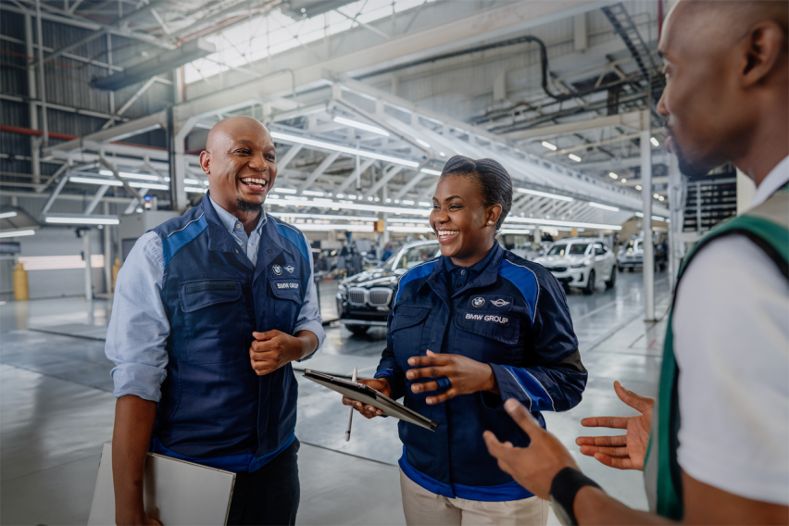Just as we care deeply for the people and processes throughout our supply chain, we know that BMW thrives because of the dedicated individuals who bring our vision to life. Also, our commitment to a better world doesn’t stop at responsibly sourcing raw materials, it extends to how we handle secondary materials as well. By continuing our efforts beyond the initial supply chain, we ensure that our planet remains at the heart of everything we do.

We nurture from within: OPTION 9: Employees.

Secondary materials become the protagonist: OPTION 8: CIRCULAR ECONOMY

—----------------------------------FIM OPTION 5 “CHILE” —-------------------------------

OPTION 6 “INDONESIA”

CAROUSEL

********************************CARD 1******************************

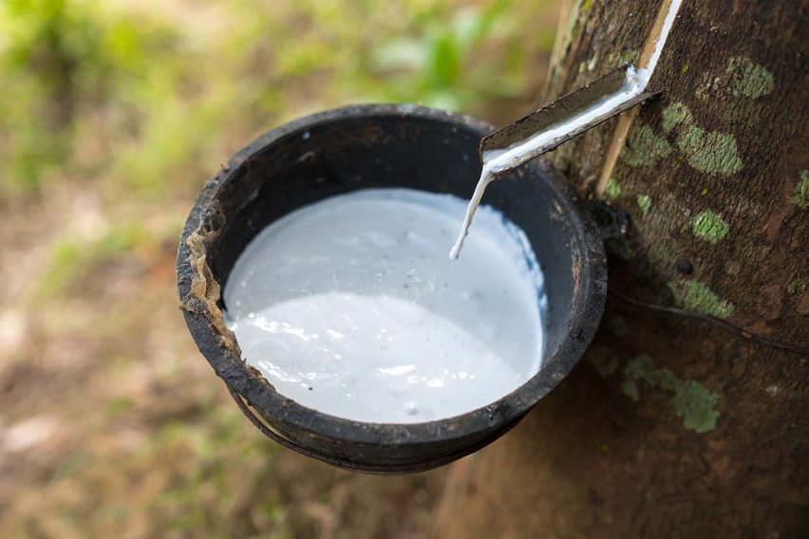The Living Rubber project in Sumatra, Indonesia, focuses on protecting Hutan Harapan. This is the island’s last large lowland rainforest on mineral soil, spanning about 100,000 hectares. This unique forest is home to hundreds of rare species, including critically endangered Sumatran tigers, Asian elephants, and hornbills.

Since 2007, local communities, PT Restoration Ecosystem Indonesia (PT REKI, a legal entity of Burung Indonesia), the Royal Society for the Protection of Birds (RSPB), BirdLife International, and KfW Development Bank (2019–2026) have worked together to protect and restore Hutan Harapan. The project contributes to the UN Decade on Ecosystem Restoration (2021–2030) and is supported by the International Climate Initiative (IKI) of the German Federal Ministry for the Environment, Nature Conservation, Nuclear Safety and Consumer Protection (BMUV).

********************************CARD 2******************************



**Biodiversity Conservation** Sumatra’s lowland forests have been drastically reduced by agricultural expansion (including rubber and palm oil) and infrastructure projects, threatening biodiversity and endangered species such as the Sumatran tiger and Helmeted Hornbill.  
*The Living Rubber project focuses on conserving biodiversity by protecting a 2,700-hectare deforestation-free area within Hutan Harapan and promoting sustainable land management.*

********************************CARD 3******************************



**Livelihood Improvement** Local and indigenous communities rely on natural rubber for income but face low productivity, inconsistent quality, limited market access, and price volatility, increasing economic insecurity.  
*The project aims to improve livelihoods by professionalizing traditional cultivation, promoting agroforestry for income diversification, and supporting the development of socially and environmentally resilient supply chains.*

********************************CARD 4******************************

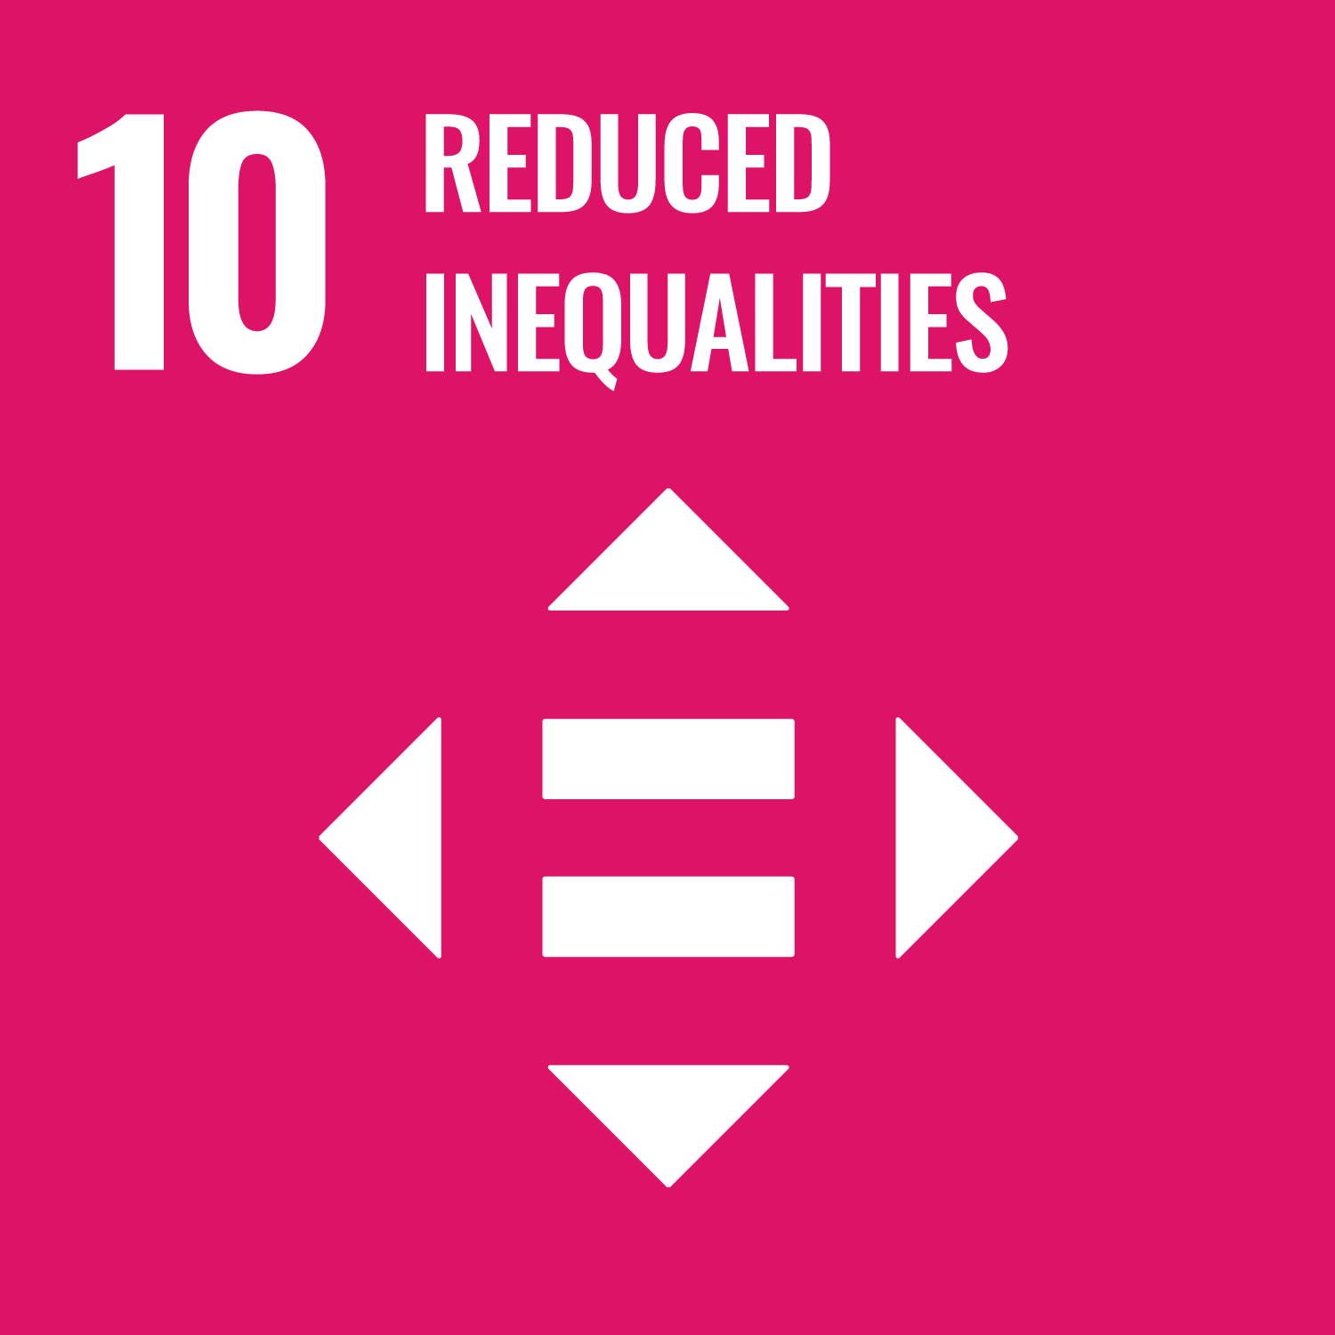

**Land Rights Protection** Land tenure conflicts are common, with many farmers lacking official land certificates and facing risks of displacement.  
 *The project works to identify, respect, and help protect farmers’ land rights, supporting secure access to land and resources.*

********************************CARD 5******************************

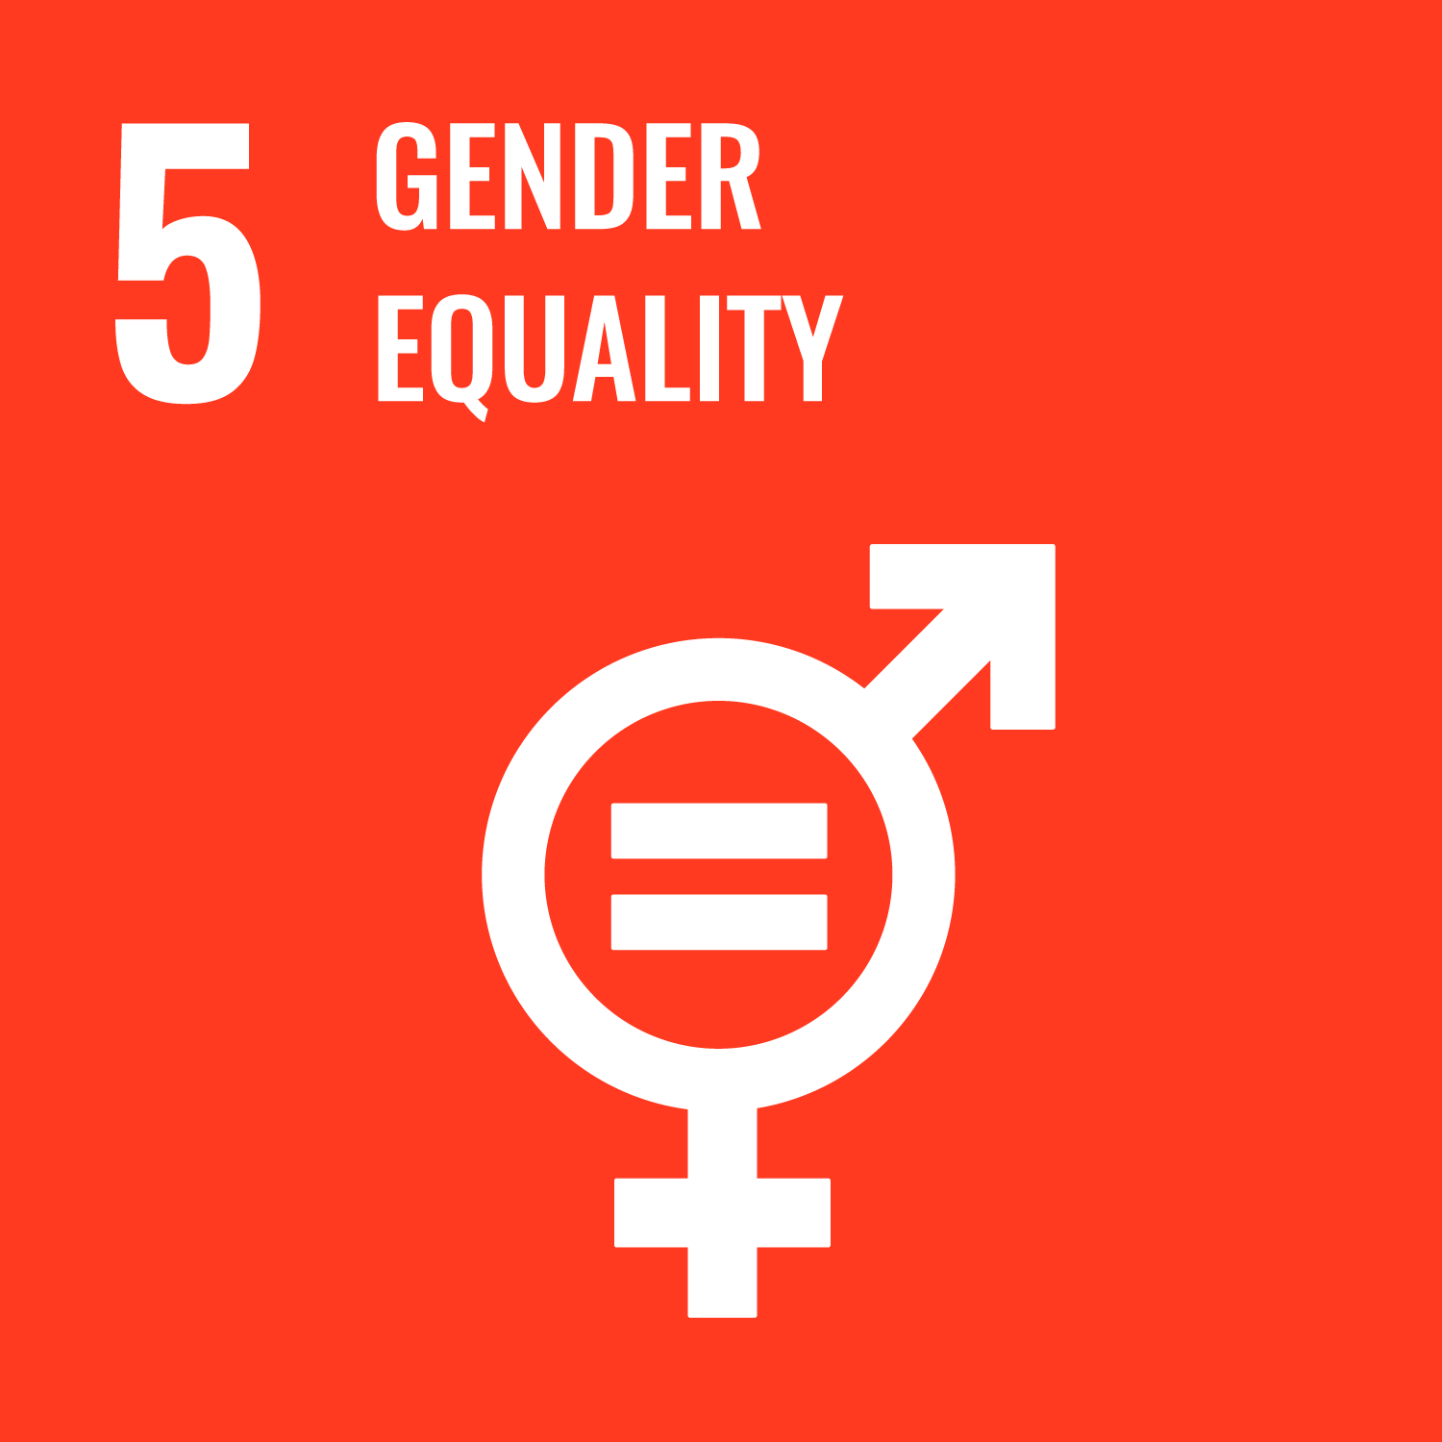

**Training and Empowerment** Monoculture farming and limited access to technology or infrastructure restrict development and income diversification.  
 *Living Rubber provides training on good agricultural practices, plantation management, and environmental stewardship, empowering farmers and offering skill-building opportunities, especially for women.*

********************************CARD 6******************************

**

**Sustainable agriculture** Forest destruction threatens traditional livelihoods and access to resources for local communities.  
 *By supporting sustainable agriculture and forest conservation, the project helps preserve community livelihoods and cultural heritage.*

********************************CARD 7******************************

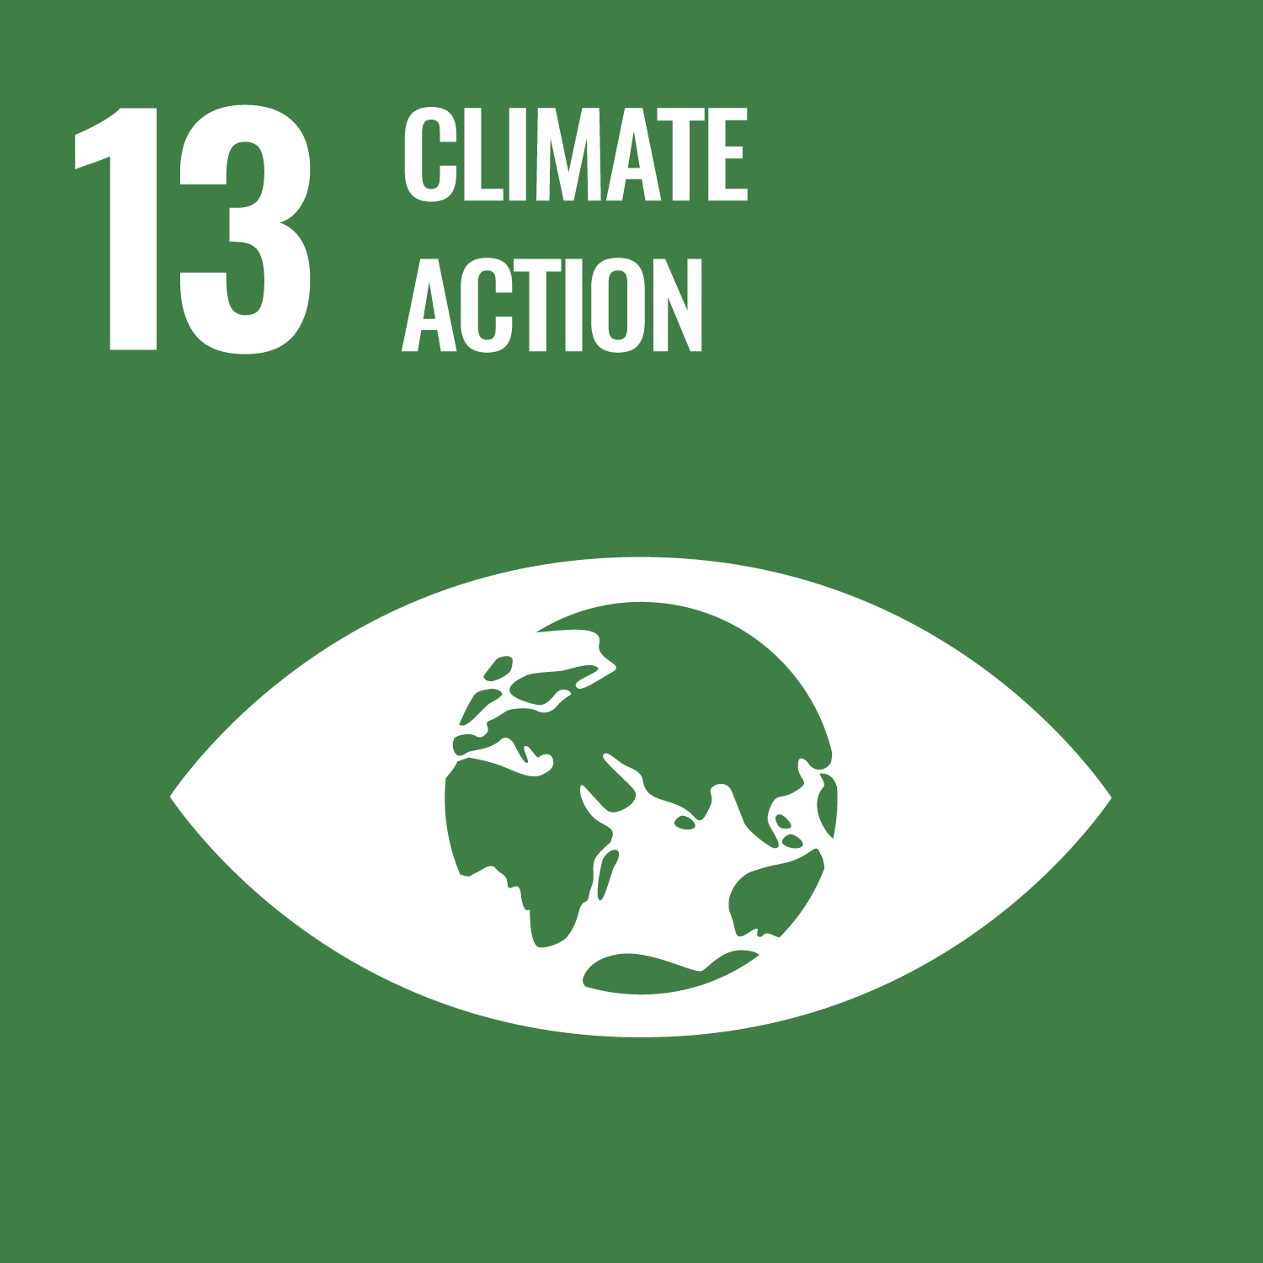

**Traceability and Sustainability Standards** Much of smallholder rubber production lacks traceability, making it difficult to ensure compliance with environmental and social standards.  
 *The project supports the creation of natural rubber Growers’ Cooperatives and introduces documentation systems to improve traceability from plantation to processor.*

********************************CARD 8******************************



**Group Collaboration** Sustainable progress requires coordinated action across the value chain.  
 *Involves multiple stakeholders, including local communities, government agencies, and the entire natural rubber value chain, to align efforts towards sustainable management.*

********************************CARD 9******************************

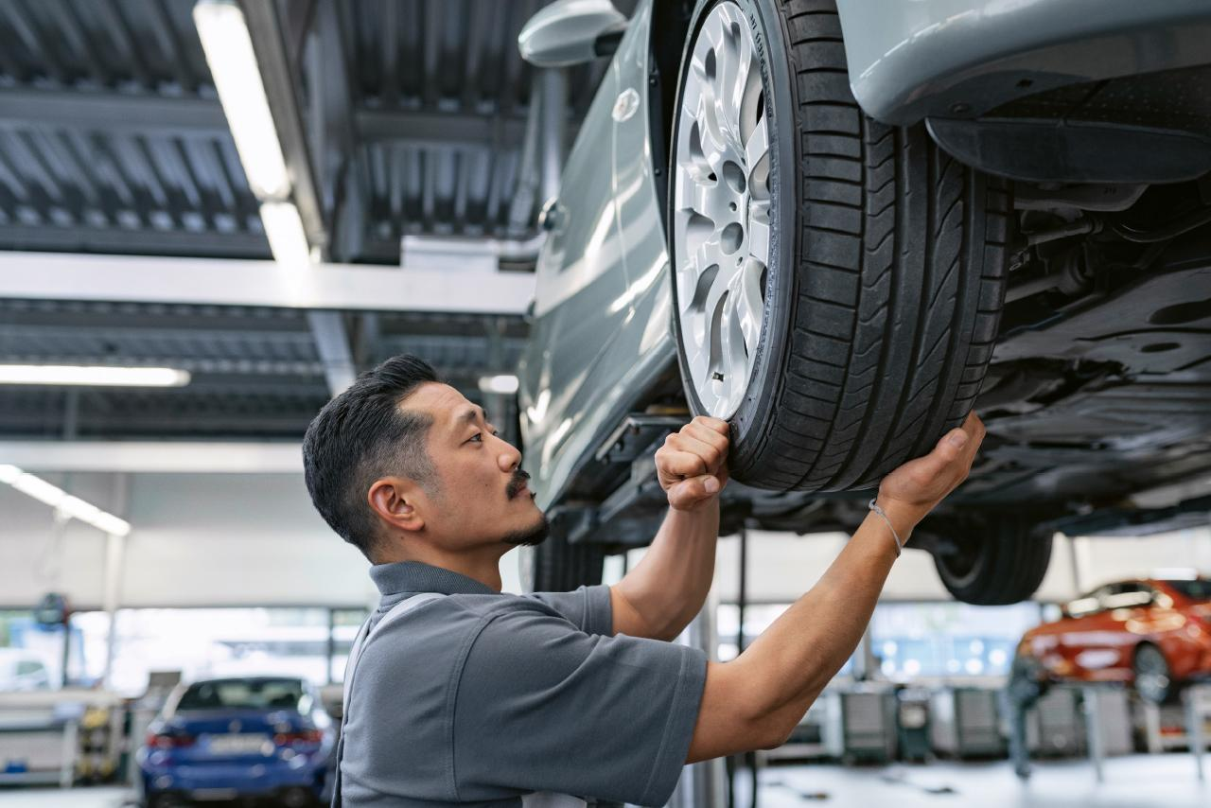

Just as we care deeply for the people and processes throughout our supply chain, we know that BMW thrives because of the dedicated individuals who bring our vision to life. Also, our commitment to a better world doesn’t stop at responsibly sourcing raw materials, it extends to how we handle secondary materials as well. By continuing our efforts beyond the initial supply chain, we ensure that our planet remains at the heart of everything we do.

We nurture from within: OPTION 9: Employees.

Secondary materials become the protagonist: OPTION 8: CIRCULAR ECONOMY

—--------------------------FIM OPTION 6 “INDONESIA”------------------------------------

OPTION 7 “INDIA”

CAROUSEL

********************************CARD 1******************************

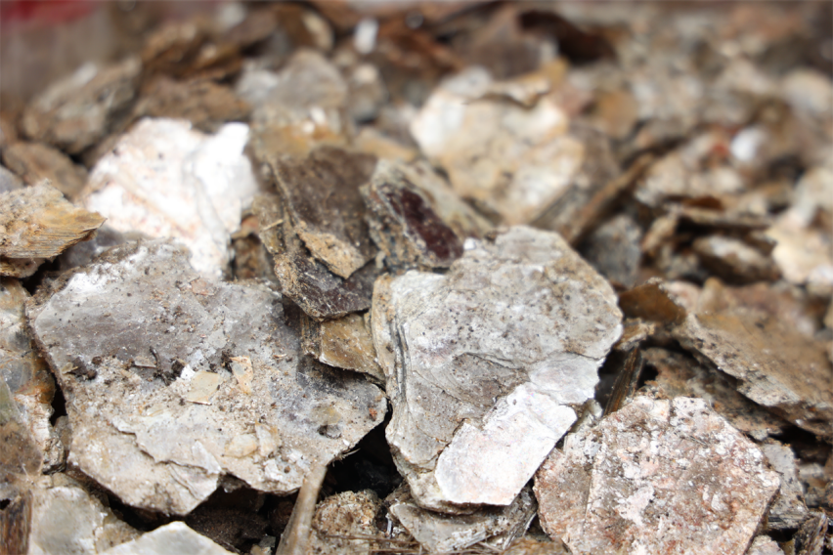The BMW Group actively supports this project by helping KSCF implement its "Child-friendly Village" model in **20 villages** within Jharkhand and Bihar, India’s Mica Belt. This partnership contributes to the overall goal of creating an ecosystem where children's rights are protected, ensuring they are safe, free, healthy, and educated.

********************************CARD 2******************************



**Children's Protection** In Jharkhand and Bihar’s mica belt, widespread poverty forces many children into hazardous labor, including mica mining, to support their families.  
 *The project’s core objective is to end child labor by ensuring children have regular access to education and attend school, breaking the cycle of economic exploitation.* Alongside child labor, child trafficking and early marriage are prevalent, further endangering vulnerable children.  
 *The initiative provides holistic child protection, acting as a one-stop solution to address not only child labor but also child trafficking, child marriage, and child sexual abuse.*

********************************CARD 3******************************

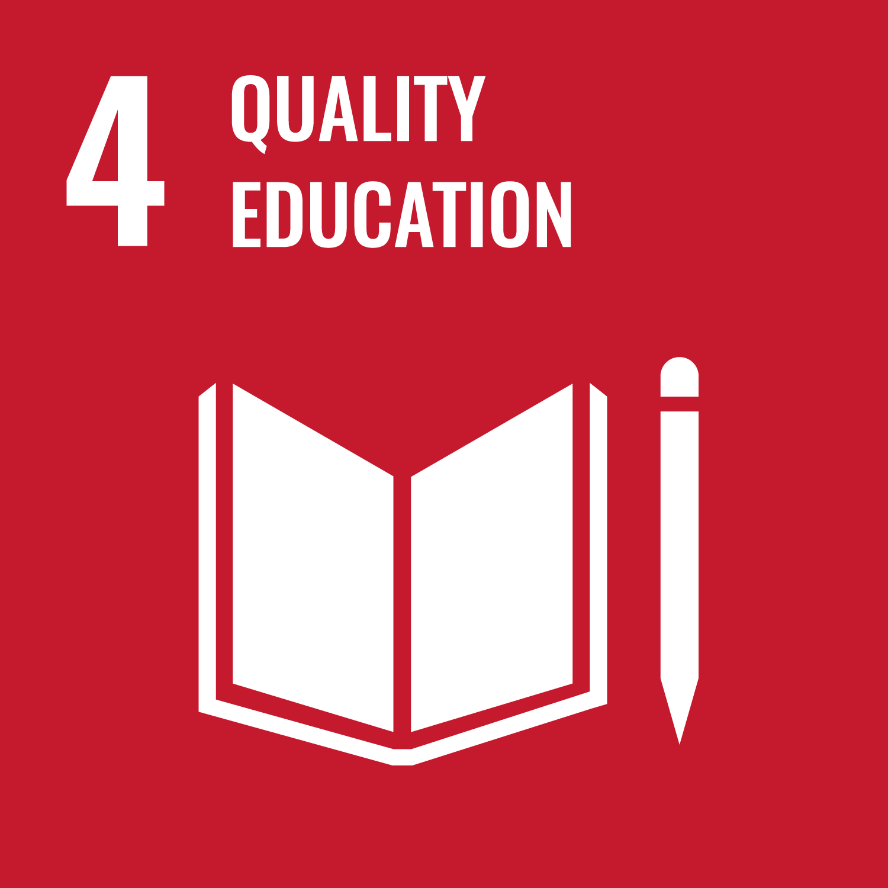

**Access to education** Children are often denied schooling due to work obligations or inadequate educational infrastructure, such as distant schools, a shortage of teachers, or lack of basic facilities.  
 *The project promotes education by mainstreaming children into schools and working to improve school infrastructure, making education accessible and appealing.*

********************************CARD 4****************************** 

**Healthier environment** Many communities lack adequate water, sanitation, and hygiene (WASH) facilities, negatively impacting children’s health and well-being.  
 *By advocating for improved school infrastructure and community facilities, the project helps create safer, healthier environments for children.*

********************************CARD 5******************************



**Rights Awareness** There is often limited awareness of basic human rights, child rights, and access to government welfare schemes among community members.  
 *The project empowers community-based stakeholders through a rights-based approach, enabling democratic participation and helping communities overcome systemic barriers to justice and welfare.*

**Political Awareness** Marginalized communities have faced discrimination for generations, perpetuating cycles of poverty and child labor.  
 *Through awareness campaigns, KSCF brings issues like forced labor and violence against children to the attention of political and social institutions, while empowering communities to claim their rights and build a better future.*

********************************CARD 6******************************

Just as we care deeply for the people and processes throughout our supply chain, we know that BMW thrives because of the dedicated individuals who bring our vision to life. Also, our commitment to a better world doesn’t stop at responsibly sourcing raw materials, it extends to how we handle secondary materials as well. By continuing our efforts beyond the initial supply chain, we ensure that our planet remains at the heart of everything we do.

We nurture from within: OPTION 9: Employees.

Secondary materials become the protagonist: OPTION 8: CIRCULAR ECONOMY

—---------------------------------FIM OPTION 7 “INDIA”------------------------------------

OPTION 8: CIRCULAR ECONOMY

CAROUSEL

********************************CARD 1******************************

[*https://www.bmwgroup.com/en/sustainability/circular-economy.html#accordion-011eb2b3a9-item-78b53a4d24*](https://www.bmwgroup.com/en/sustainability/circular-economy.html#accordion-011eb2b3a9-item-78b53a4d24) *reference link*

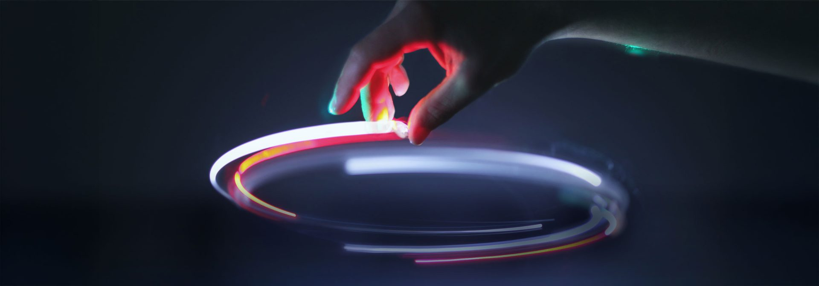Raw materials are only part of the story. Secondary materials play an equally crucial role in our vision for the future and that’s where the circular economy comes in. We’ve brought this concept to life with vehicles like the BMW i Vision Circular, which demonstrated how a car could be produced entirely from secondary materials. This pioneering initiative not only showcased the possibilities, but also highlighted the complexities and challenges involved in making large-scale use of recycled materials in automotive manufacturing.

[*https://www.bmwgroup.com/en/sustainability.html#carousel-f9cdf9ea9e-item-9e54d5aadd-tabpanel*](https://www.bmwgroup.com/en/sustainability.html#carousel-f9cdf9ea9e-item-9e54d5aadd-tabpanel) *reference link*

********************************CARD 2******************************



**Reducing Environmental Impact** We aim to lower CO₂e emissions and minimize the environmental and social impacts of raw material extraction.

**Maximizing Resource Efficiency** We keep materials in use as long as possible, maintaining their value in a continuous cycle.

**Design for Circularity** We integrate circular design by using more recycled materials without compromising quality or safety, selecting materials for easy recovery, and designing components for simple, cost-effective disassembly and recycling.

********************************CARD 3******************************



**Vehicle and Component Recycling** For over 30 years, our Recycling and Dismantling Centre (RDZ) has developed advanced recycling processes, directly influencing new vehicle design. We work with global partners and maintain a recycling database used by 3,000 businesses in 23 countries to guide efficient dismantling and material recovery.

**Battery Recycling** Since late 2024, our closed-loop battery system recovers and reuses critical materials like cobalt, nickel, and lithium, feeding them back into new battery production.

********************************CARD 4******************************



**Resource-Efficient Production** We have consistently reduced non-recyclable waste and water consumption per vehicle, water use dropped from 1.90 m³ in 2022 to 1.67 m³ in 2024, and non-recyclable waste from 2.74 kg to 1.68 kg.

Through these measures, we are building a more sustainable future, one innovation at a time.

The builders of such future are also taken care of : OPTION 9: Employees. (carousel)

—----------------FIM OPTION 8: CIRCULAR ECONOMY—------------------------------

OPTION 9: Employees

CAROUSEL

********************************CARD 1******************************

[*https://www.bmwgroup.com/en/sustainability/employees.html*](https://www.bmwgroup.com/en/sustainability/employees.html) *reference link*

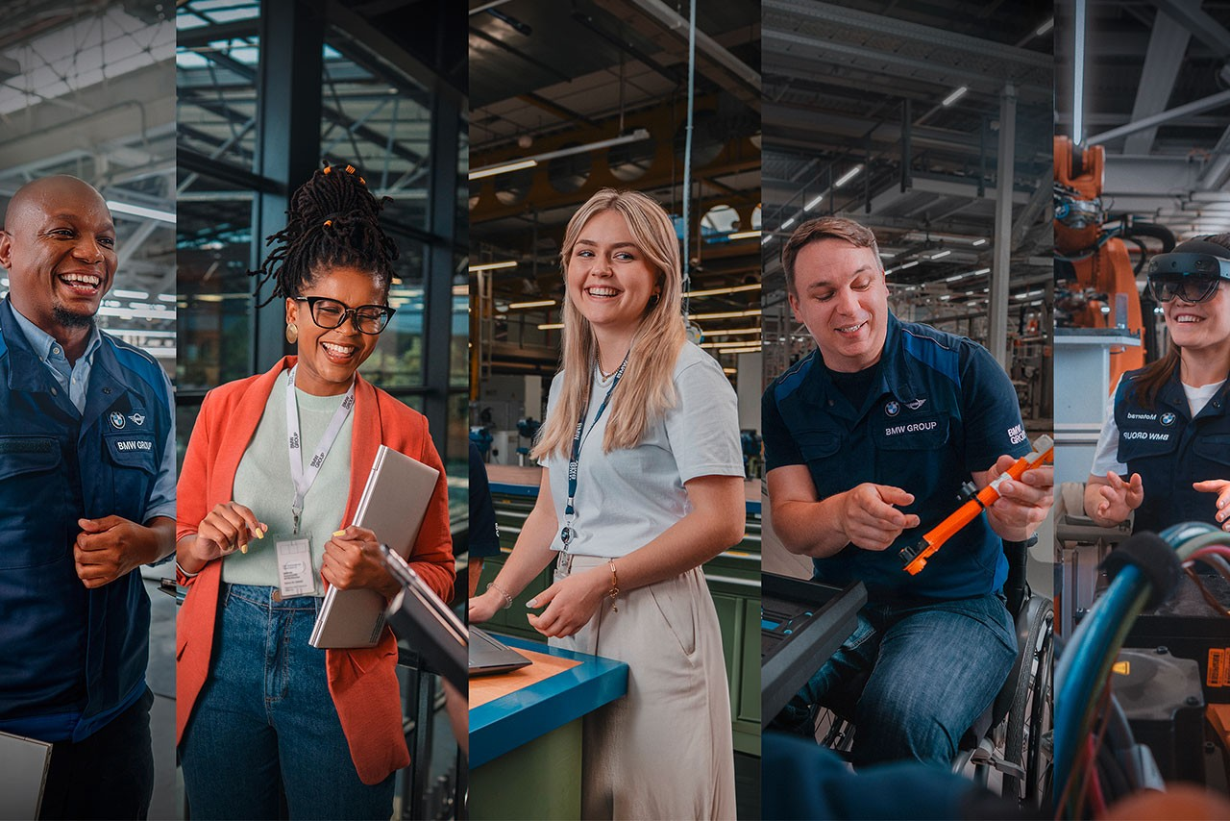The BMW Group embraces people of all personalities, backgrounds, abilities, perspectives, and lifestyles, believing that diversity is key to meeting future challenges. Every employee identifies with our company’s vision, bringing passion, initiative, and team spirit to achieve extraordinary results. Their commitment and enthusiasm are the foundation of our innovation, performance, and customer satisfaction.

At BMW Group, our 154,000 employees are the driving force behind our pioneering spirit and sustainable future. We invest in their growth, well-being, and inclusion, knowing their passion and expertise shape the premium mobility of tomorrow.

********************************CARD 2******************************



**Valuing and Supporting Our People**

We celebrate our employees’ skills and commitment, offering secure, future-oriented jobs in an environment built on respect and inclusion. Discrimination has no place here. Every individual is empowered to reach their full potential.

**Diversity and Inclusion**

Diversity is key to our success. We embrace people of all backgrounds, abilities, and lifestyles, supporting gender parity, intergenerational cooperation, and the LGBTIQ+ community. Our global workforce represents over 110 nations, fostering cultural exchange and understanding.

********************************CARD 3******************************



**Training, Development, and Career Growth**

Continuous learning is at our core. The BMW Group Academy provides over a million training opportunities annually, from e-mobility and data analytics to language skills. We support young talent with vocational training in 30 professions and 20 dual-study courses, and offer targeted programs like ProMotion PhD, AcceleratiON, and FastLane to develop future leaders.

********************************CARD 4******************************



**Well-being and Work Environment**

Employee health is a top priority. We provide health-friendly workplaces, in-house fitness centers, flexible work models, and comprehensive support for work-life balance. Our centrally located offices ensure easy access, and we uphold the highest standards in health and safety.

**Social and Cultural Engagement**

We encourage employees to give back through volunteering, supported by our SOCIAL DRIVE platform and the BMW Group Award for Social Engagement. Our vibrant cultural life includes employee-led initiatives like the BMW Chamber Orchestra, Dixi Drivers band, and the Kulturmobile program.

Our commitment doesn’t stop at our factory gates. Every step we take to care for something comes full circle, giving back in ways that strengthen the whole. That’s the essence of a circular world: each action becomes part of a greater system, where responsibility and progress continuously reinforce one another, driving us all forward. That's why we encourage our employees to extend their care to society as a whole, nurturing the communities in which we live and work.

Learn how BMW employees engage positively in society: OPTION 11: HOW DO THE EMPLOYEES ENGAGE?

—-----------------------------FIM OPTION 9: Employees—--------------------------------

OPTION 11: HOW DO THE EMPLOYEES ENGAGE?

CAROUSEL

********************************CARD 1******************************

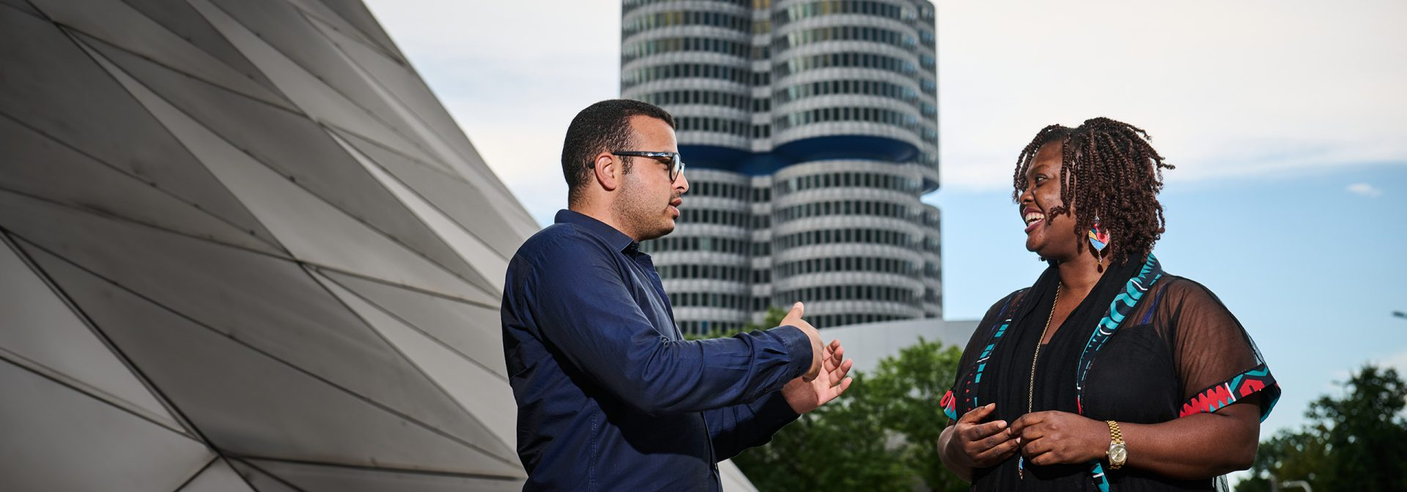**BMW Group Award for Social Engagement** Under the motto “We Love What You Do!”, the BMW Group has honored outstanding volunteers with the BMW Group Awards for Social Engagement since 2011. These awards recognize employees who show exceptional commitment to social and environmental projects.

********************************CARD 2******************************

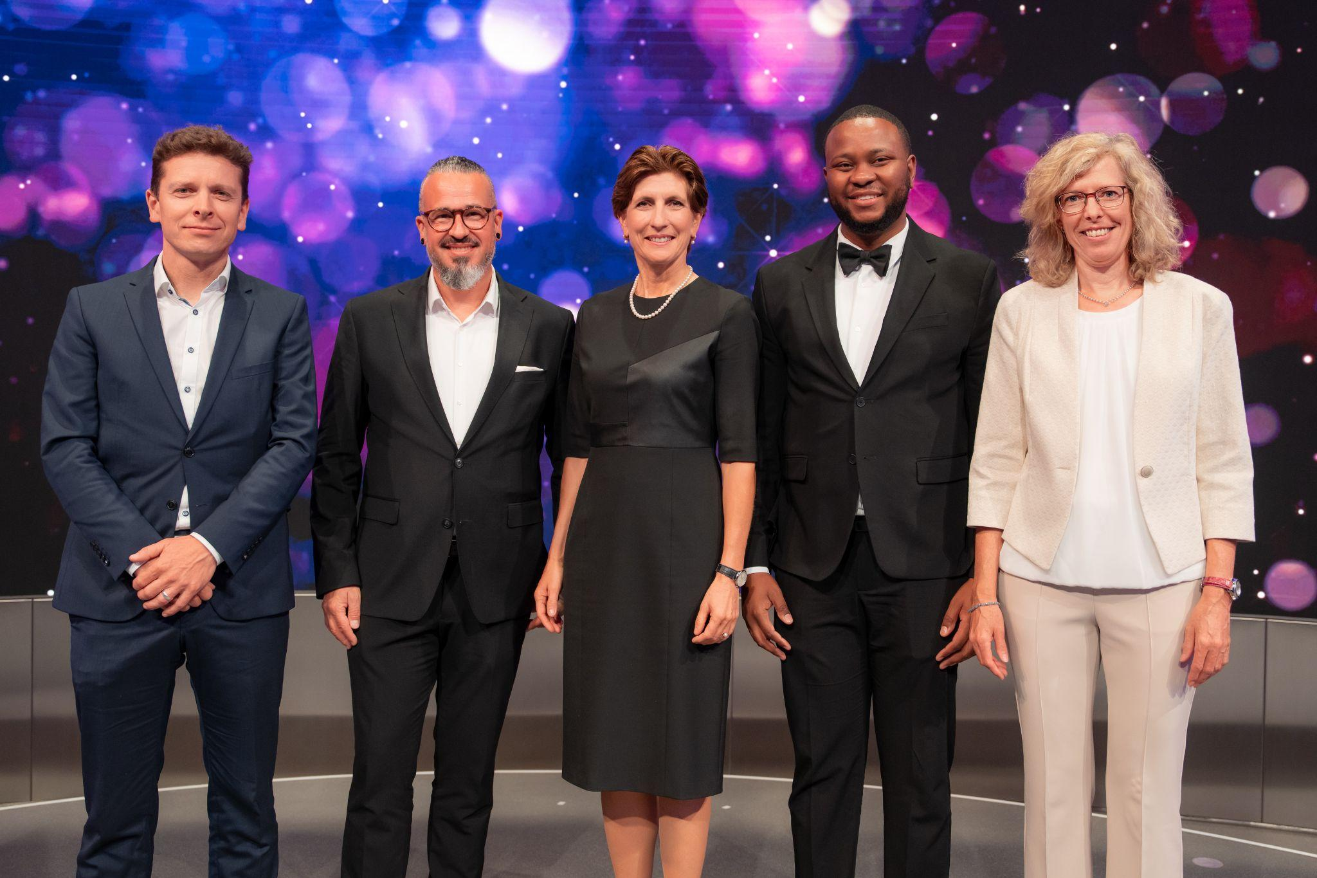

**Social Drive Platform** The SOCIAL DRIVE platform supports employee volunteering by listing a wide range of opportunities and activities, making it easy for employees to get involved and connect with like-minded partners for their projects.

********************************CARD 3******************************

**Kulturmobile** For over 50 years, the BMW Group has supported diverse cultural initiatives worldwide. Through the Kulturmobile platform, employees can stay informed about cultural events (both public and company-organized) including exclusive partner events.

********************************CARD 4******************************

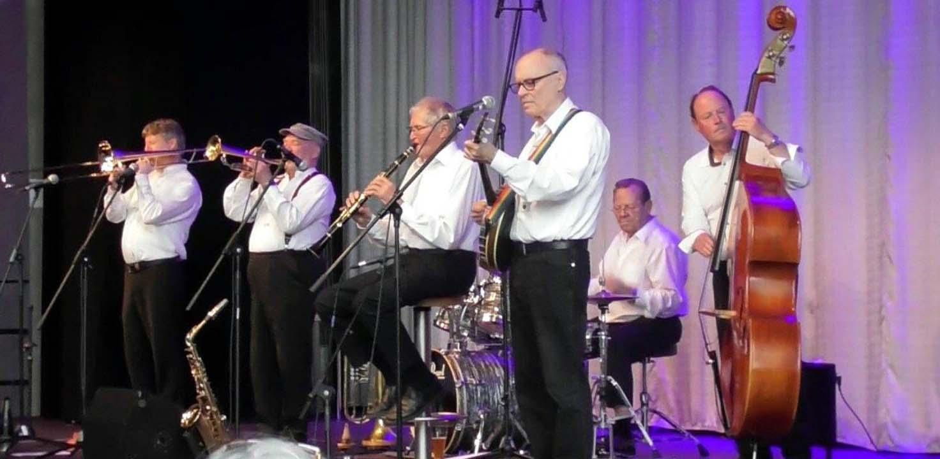**Cultural Employee Initiatives** BMW employees actively contribute to the company’s cultural life. The BMW Chamber Orchestra has delighted audiences since 1996, while the Dixi Drivers band (named after BMW’s first car) has been playing Dixieland and blues since 1983. Many other employee-led initiatives span music and the performing arts, enriching the company’s vibrant cultural community.

—-----------FIM OPTION 11: HOW DO THE EMPLOYEES ENGAGE? —-----------

## DIGITAL JOURNEY

RICH CARD

[*https://www.bmw.com/en/digital-journey.html*](https://www.bmw.com/en/digital-journey.html) *reference link*

Throughout history, humanity has always lived for “firsts”. From the moment we lightened our load with the invention of the wheel, every breakthrough set us on a path of invention, each new “first” building on the last, sometimes in leaps, sometimes in small but vital steps.

Since the turn of the millennium, digital innovation has accelerated at an unprecedented pace, transforming the way we live and drive. The journey that began with a wheel led to the very first car, and now, our cars have crossed a new threshold, blending mechanical mastery with digital brilliance.

Sheer driving pleasure isn’t just preserved, it’s reimagined, expanded, and electrified by every new breakthrough. At BMW, we live for these moments. Every innovation, every “first,” is another chapter in our story. We are always moving forward, always driven by joy.

OPTION: Explore our creations

Explore our creations:

CAROUSEL

********************************CARD 1******************************

Series: 

[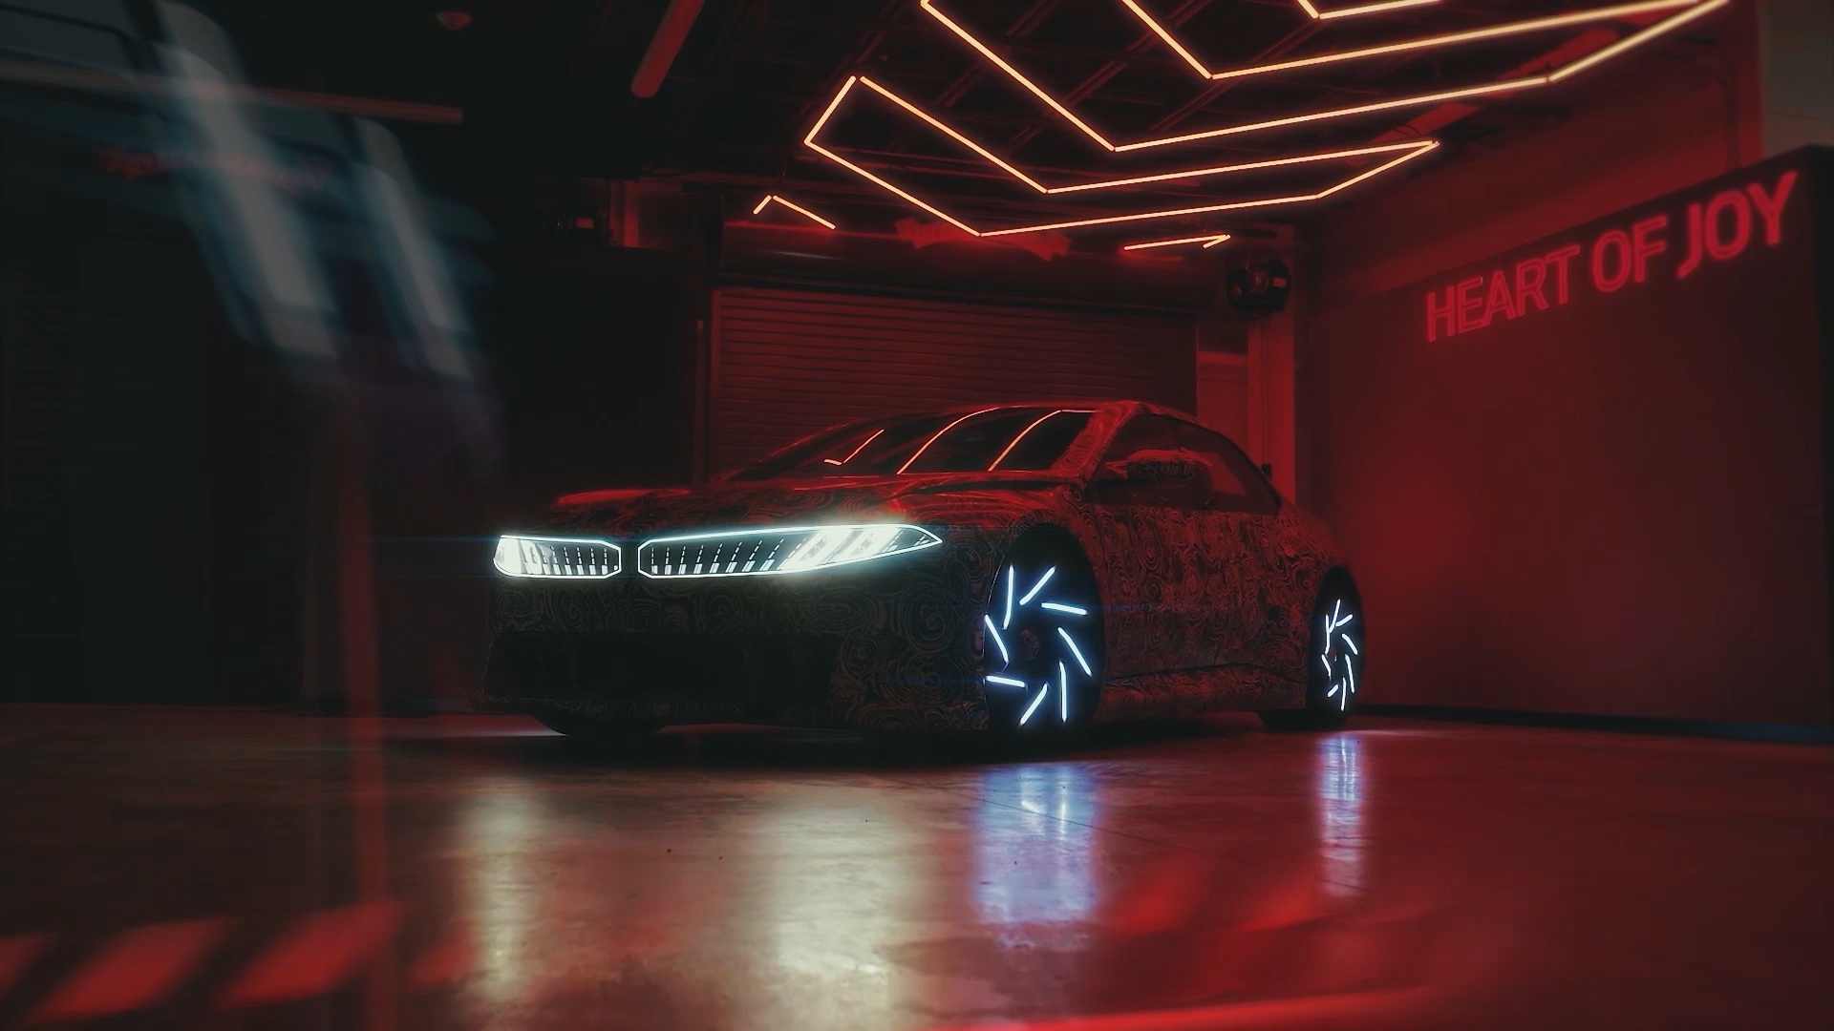](https://www.bmw.com/en/digital-journey/inside-neue-klasse-bmw-heart-of-joy.html)

**[Inside Neue Klasse](https://www.bmw.com/en/digital-journey/inside-neue-klasse-bmw-heart-of-joy.html)**

### **[The Heart of Joy – Redefining driving pleasure](https://www.bmw.com/en/digital-journey/inside-neue-klasse-bmw-heart-of-joy.html)**

********************************CARD 2******************************

[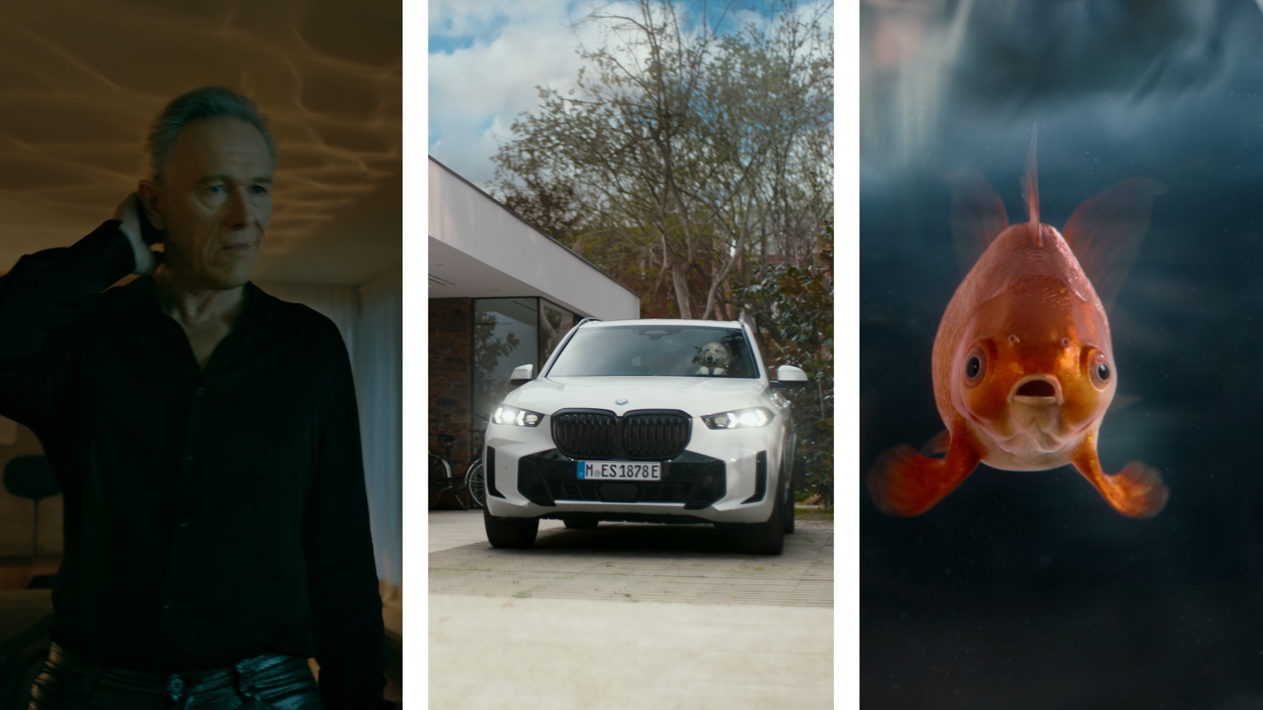](https://www.bmw.com/en/digital-journey/bmw-intelligence.html)

**[Innovation](https://www.bmw.com/en/digital-journey/bmw-intelligence.html)**

### **[BMW Intelligence](https://www.bmw.com/en/digital-journey/bmw-intelligence.html)**

********************************CARD 3******************************

About the IDRIVE

[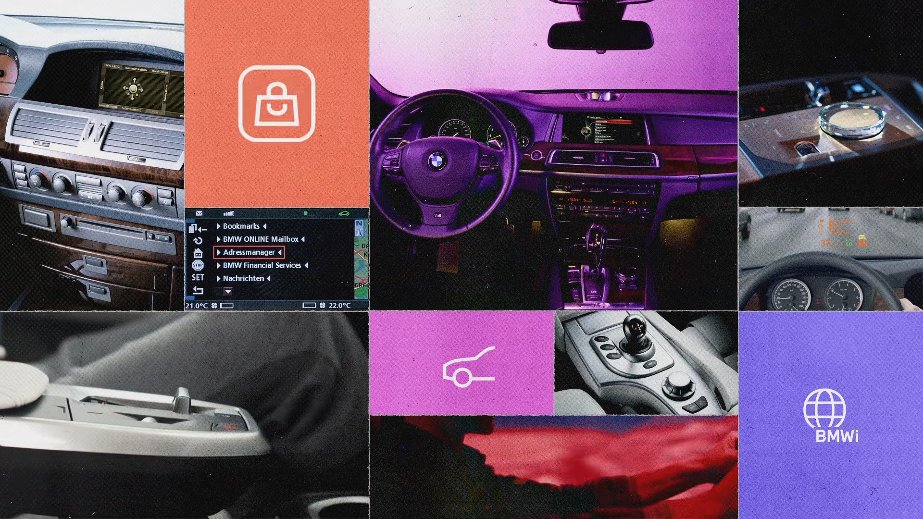](https://www.bmw.com/en/digital-journey/evolution-of-the-bmw-idrive.html)

**[BMW iDrive](https://www.bmw.com/en/digital-journey/evolution-of-the-bmw-idrive.html)**

### **[An Evolution of Control and Intelligent Connectivity](https://www.bmw.com/en/digital-journey/evolution-of-the-bmw-idrive.html)**

********************************CARD 4******************************

ABOUT THE SMART ASSISTANCE

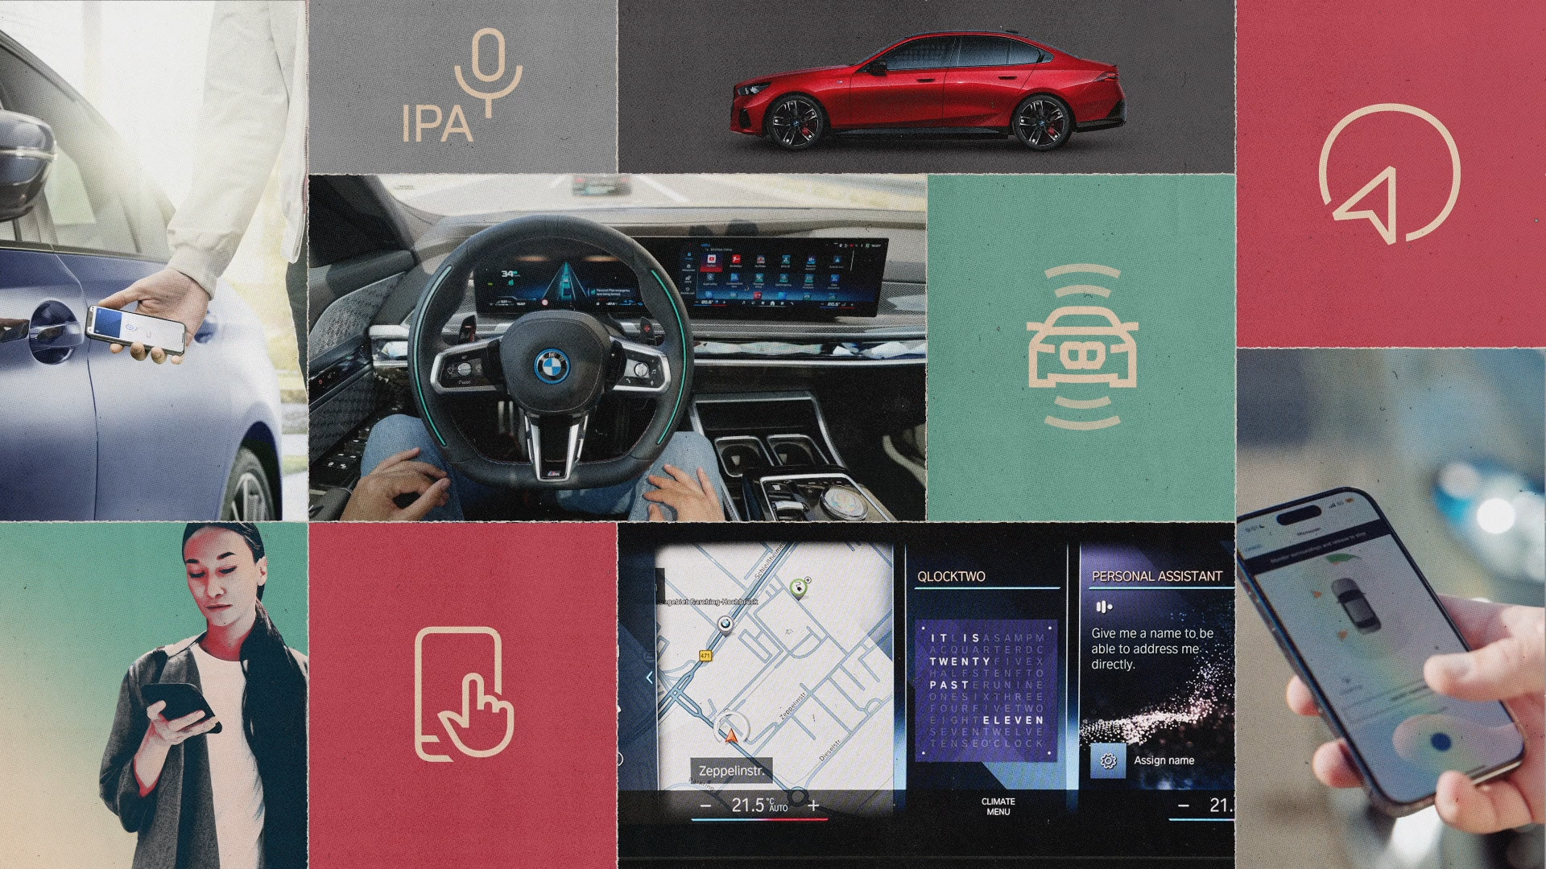

**[Smart Assistance](https://www.bmw.com/en/digital-journey/smart-driver-assistance.html)**

### **[The BMW Driving Companionship](https://www.bmw.com/en/digital-journey/smart-driver-assistance.html)**

********************************CARD 5******************************

**DEE MY GUEST**

Join us for an audio series exploring the fascinating relationship between humans and machines, through the lens of our seven senses: sight, hearing, smell, taste, touch, intuition, and balance. These senses shape how we experience the world. But what if we could perceive all this in a digital realm? Travel the globe with Dee, your ultimate companion, and meet the innovators who are building bridges between the real and virtual worlds.

<https://www.bmw.com/en/podcasts/dee-my-guest.html>

—----------------------FIM OPTION: Explore our creations —------------------------------

# ELECTRIC FUTURE

RICH CARD

[*https://www.bmw.com/en/electric-future.html*](https://www.bmw.com/en/electric-future.html) *reference link*

The present is already paving the way to the electric future. From today’s cutting-edge electric technologies to hydrogen and beyond, the future is starting to be full of opportunities for a greener, more sustainable society, and we’re excited to lead the way.

OPTION: Explore the path that's leading to tomorrow.



[](https://www.bmw.com/en/electric-future/hydrogen-milestones-pioneering-spirit-for-the-mobility-of-the-future.html)Explore the path that's leading to tomorrow.

CAROUSEL

********************************CARD 1******************************

[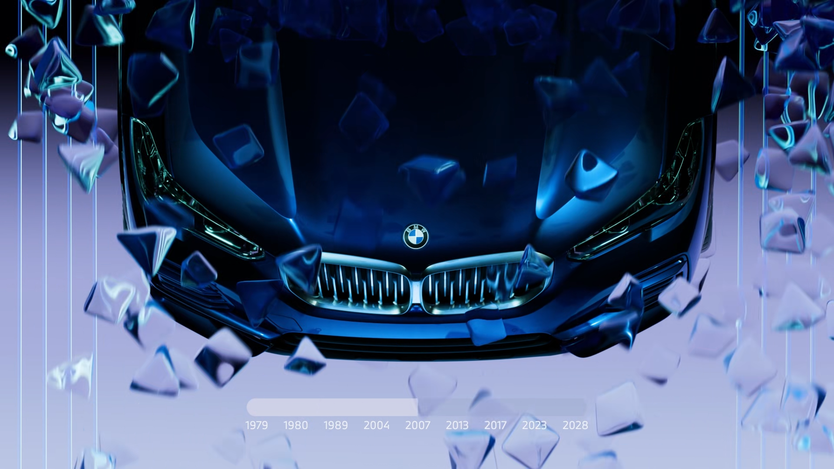](https://www.bmw.com/en/electric-future/hydrogen-milestones-pioneering-spirit-for-the-mobility-of-the-future.html)**[Hydrogen](https://www.bmw.com/en/electric-future/hydrogen-milestones-pioneering-spirit-for-the-mobility-of-the-future.html)**

### [**The BMW journey to the mobility of the future**](https://www.bmw.com/en/electric-future/hydrogen-milestones-pioneering-spirit-for-the-mobility-of-the-future.html)

********************************CARD 2******************************



[](https://www.bmw.com/en/digital-journey/startups-and-the-future-of-mobility-with-alexandra-renner.html)**[Audio column](https://www.bmw.com/en/digital-journey/startups-and-the-future-of-mobility-with-alexandra-renner.html)**

### **[The future of startups in the automotive industry](https://www.bmw.com/en/digital-journey/startups-and-the-future-of-mobility-with-alexandra-renner.html)**



[](https://www.bmw.com/en/electric-future/electric-car-myths-podcast.html)

**[ELECTRIC MYTHS](https://www.bmw.com/en/electric-future/electric-car-myths-podcast.html)**

### **[A video podcast about electric driving myths](https://www.bmw.com/en/electric-future/electric-car-myths-podcast.html)**





**[THE ICON](https://www.bmw.com/en/electric-future/the-icon-electromobililty-on-the-water.html)**

### [**BMW as a driving force for sustainable mobility**](https://www.bmw.com/en/electric-future/the-icon-electromobililty-on-the-water.html)

********************************CARD 3******************************



**[Electrifying sound](https://www.bmw.com/en/magazine/innovation/hans-zimmer-individual-drive-sounds-as-identity-for-electric-vehicles.html)**

### **[How BMW composes the score for electric driving pleasure](https://www.bmw.com/en/magazine/innovation/hans-zimmer-individual-drive-sounds-as-identity-for-electric-vehicles.html)**



**[Electrifying passengers](https://www.bmw.com/en/magazine/innovation/supercar-blondie-hans-zimmer-drive-bmw-i4.html)**

### **[Supercar Blondie takes an electric ride with Hans Zimmer](https://www.bmw.com/en/magazine/innovation/supercar-blondie-hans-zimmer-drive-bmw-i4.html)**

-------------- FIM OPTION: Explore the path that's leading to tomorrow.---------------

# FREUDE

RICH CARD

[*https://www.bmw.com/en/freude.html*](https://www.bmw.com/en/freude.html) *reference link*

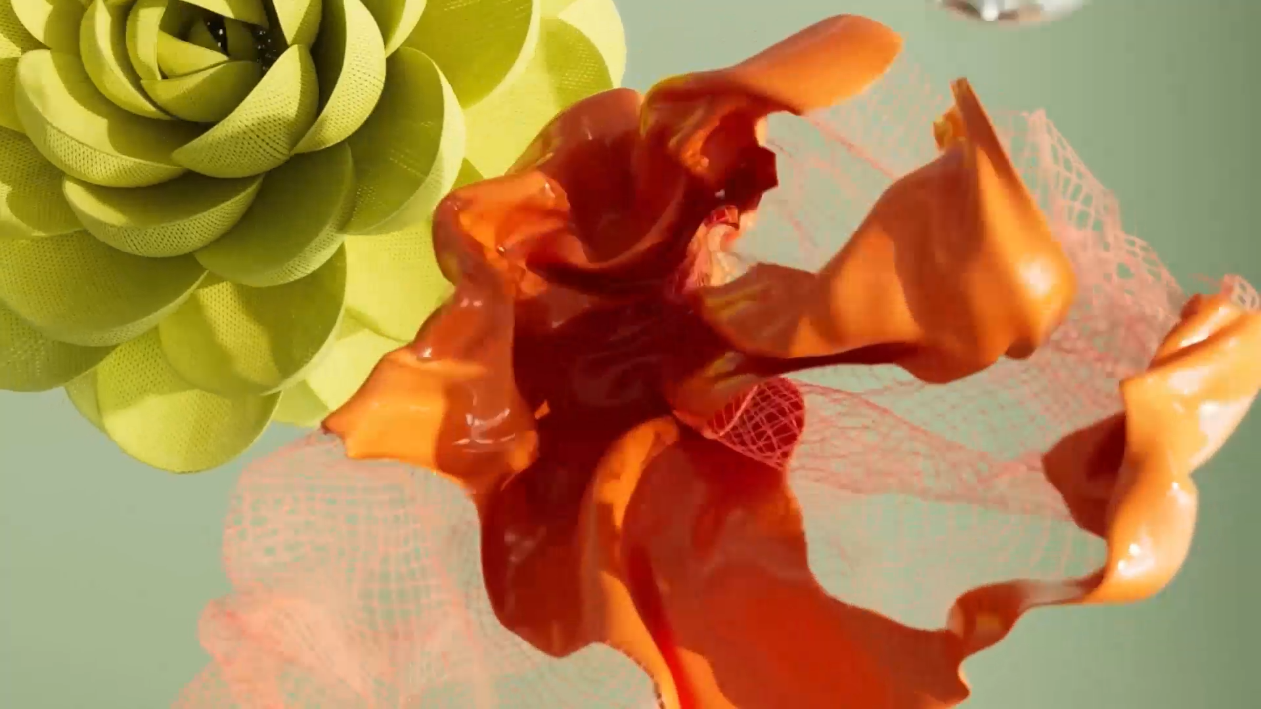For us, joy is more than a feeling, it’s a statement, the exhilaration behind every drive, and the spirit of living life with intention. Joy fuels our ambition and stands as our promise for tomorrow. It’s the spark that fills us with optimism for the future.

We believe the world around you shapes your emotions, just as it shapes ours. Here we share stories designed to inspire joy, illuminating how this powerful emotion drives our vision of mobility and shapes every journey we create.

OPTION: Sheer reading pleasure

Sheer reading pleasure

CAROUSEL

********************************CARD 1******************************



[](https://www.bmw.com/en/freude/how-bmw-shaped-the-sports-sedan.html)

[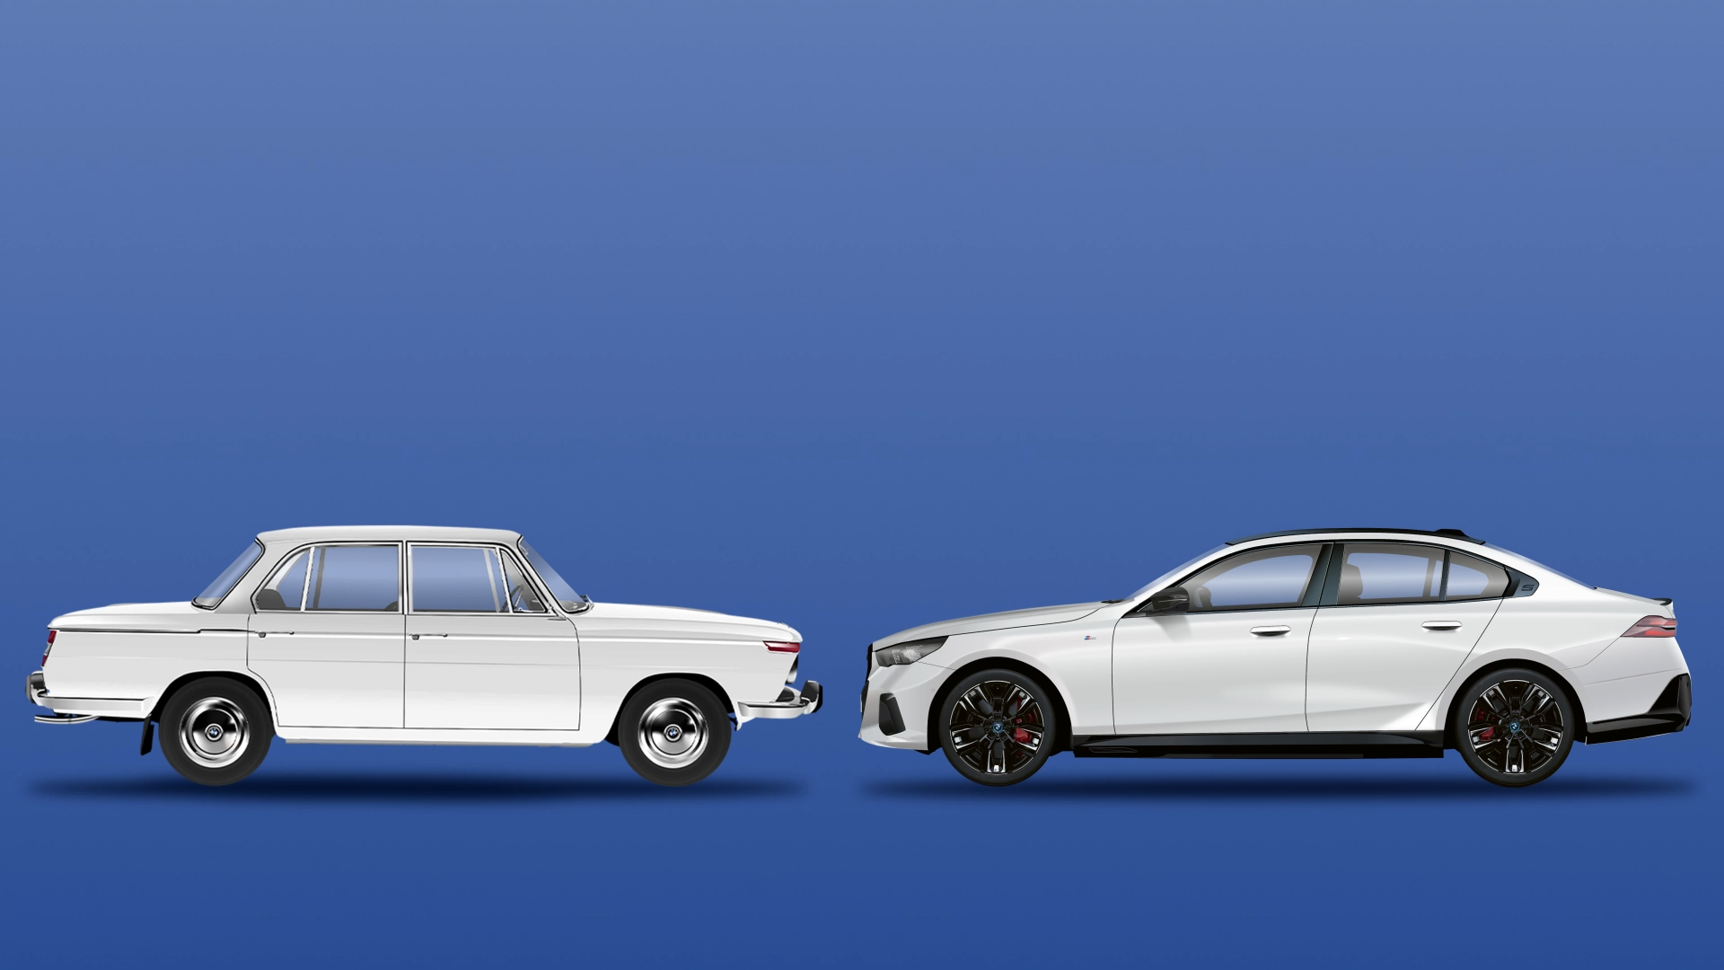](https://www.bmw.com/en/freude/how-bmw-shaped-the-sports-sedan.html)**[BMW Explained](https://www.bmw.com/en/freude/how-bmw-shaped-the-sports-sedan.html)**

### [**How BMW shaped the sports sedan**](https://www.bmw.com/en/freude/how-bmw-shaped-the-sports-sedan.html)

**[BMW explained](https://www.bmw.com/en/freude/colours-at-bmw.html)**

### [**The joy of colour**](https://www.bmw.com/en/freude/colours-at-bmw.html)



[](https://www.bmw.com/en/freude/from-april-fools-joke-to-reality-bmw-innovations.html)

********************************CARD 2******************************

[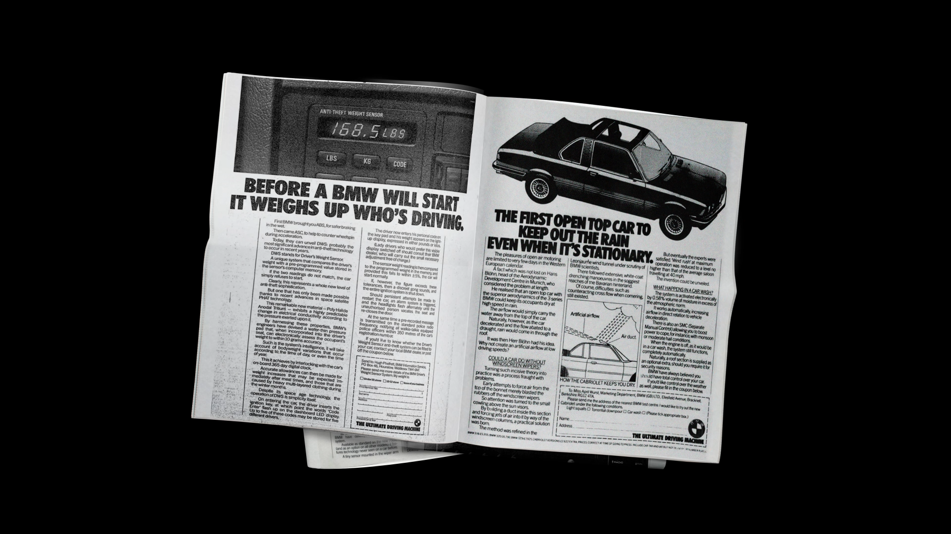](https://www.bmw.com/en/freude/from-april-fools-joke-to-reality-bmw-innovations.html)**[Technology](https://www.bmw.com/en/freude/from-april-fools-joke-to-reality-bmw-innovations.html)**

### **[From April Fool’s jokes to reality: BMW innovations ahead of their time.](https://www.bmw.com/en/freude/from-april-fools-joke-to-reality-bmw-innovations.html)**





********************************CARD 3******************************

[](https://www.bmw.com/en/freude/exciting-facts-from-the-history-of-bmw.html)

[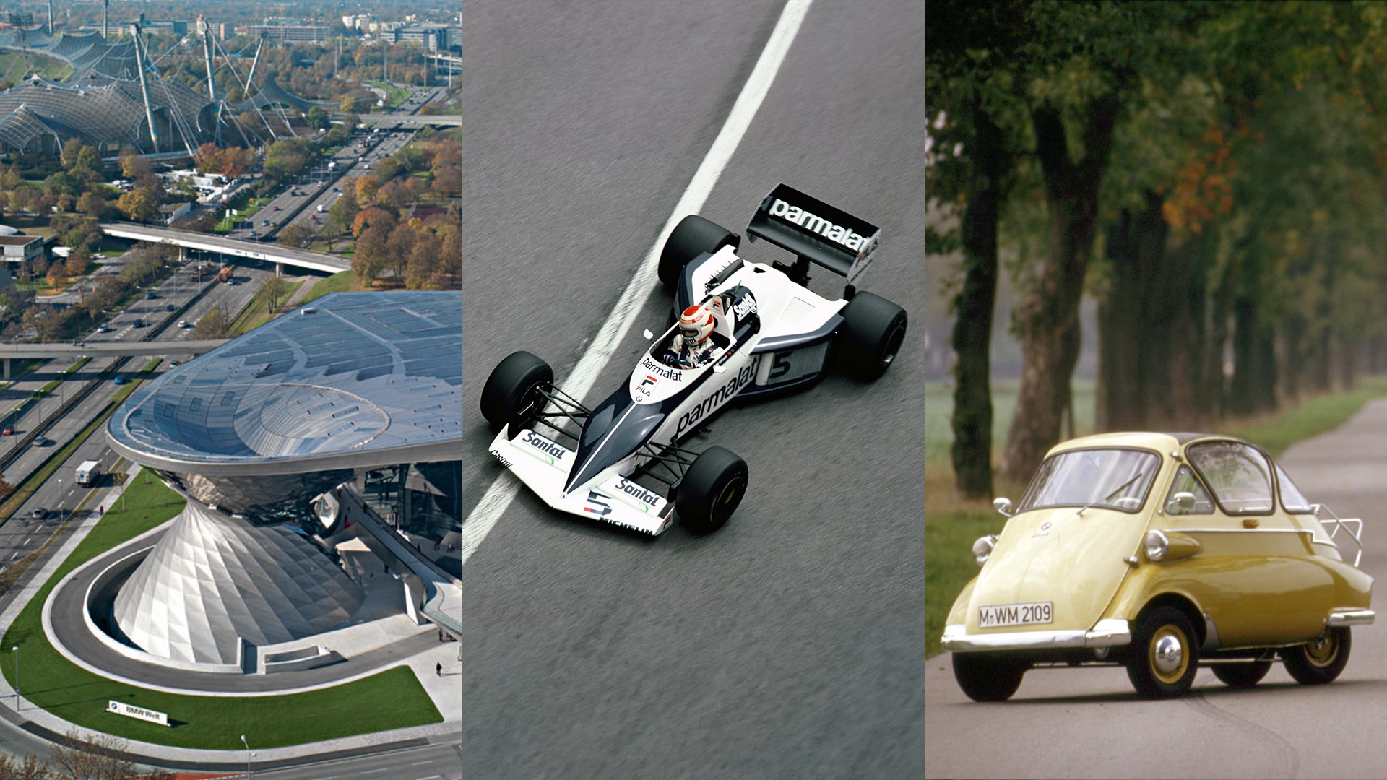](https://www.bmw.com/en/freude/exciting-facts-from-the-history-of-bmw.html)**[BMW history](https://www.bmw.com/en/freude/exciting-facts-from-the-history-of-bmw.html)**

### [**Do you know these fascinating BMW facts?**](https://www.bmw.com/en/freude/exciting-facts-from-the-history-of-bmw.html)

## QUIZ

RICH CARD

**Guess the BMW model**

Distinctive proportions, iconic design, and lines that tell a story: can you identify BMW models just by their silhouette?

OPTION: Test your knowledge with our quiz.

—---------------------------------------RICH CARD—------------------------------------------

### 

### **WHICH BMW IS SHOWN HERE?**

PHOTO

*User replies*

—---------------------------------------RICH CARD—------------------------------------------

PHOTO REVEALED

**BMW M3 (1986–1991)** You’ve just spotted the very first BMW M3 from 1986, a compact powerhouse that redefined sporty driving. This wasn’t just a car; it was the spark that ignited the M3 legend. Designed to thrill on the streets and conquer the racetrack, it set new standards for performance and passion. The original M3 didn’t just make history, it shaped the future of BMW’s driving experience.

—---------------------------------------RICH CARD—------------------------------------------

### **WHICH BMW IS SHOWN HERE?**

PHOTO

*User replies*

—---------------------------------------RICH CARD—------------------------------------------

PHOTO REVEALED

**BMW 5 Series Touring (1991–1996)** Exactly right! This silhouette belongs to the very first BMW 5 Series Touring. When it debuted in 1991, it broke new ground, introducing the estate car to the upper middle class for the first time. It was the perfect blend of sportiness, sophistication, and practicality, setting a new standard for versatile driving pleasure.

—---------------------------------------RICH CARD—------------------------------------------

### **WHAT IS HIDDEN BEHIND THIS SILHOUETTE?**

PHOTO

*User replies*

—---------------------------------------RICH CARD—------------------------------------------

PHOTO REVEALED

**BMW 8 Series (1989–1999)** Sharp eye! The pioneering blend of sleek elegance and dynamic sportiness instantly identifies this masterpiece as the 850 CSi. A BMW that was truly ahead of its era, it still mesmerizes enthusiasts today with its enduring, iconic presence.

—---------------------------------------RICH CARD—------------------------------------------

**Do you recognize this BMW?**

PHOTO

*USER REPLIES*

—---------------------------------------RICH CARD—------------------------------------------

PHOTO REVEALED

**BMW Z4 (2002–2008)** The BMW Z4’s irresistible roadster silhouette is shaped by its distinctive proportions: an elongated bonnet, a driver-focused cockpit, and a bold, compact rear. This iconic design language, introduced with the very first model, continues to define the spirit of the Z4 today.

—---------------------------------------RICH CARD—------------------------------------------

### **CAN YOU IDENTIFY THIS BMW MODEL JUST FROM ITS SILHOUETTE?**

PHOTO

*USER REP*

—---------------------------------------RICH CARD—------------------------------------------

PHOTO REVEALED

**Neue Klasse 1500 (1962–1964)** With the launch of the Neue Klasse in 1962, BMW reshaped its identity and set a new course for the future. This era introduced a design hallmark that remains a defining BMW signature: the Hofmeister kink. Crafted by Wilhelm Hofmeister and his team, the distinctive bend at the C-pillar was engineered for structural strength while delivering an unmistakable aesthetic touch, an enduring symbol recognized by enthusiasts worldwide.

—---------------------------------------RICH CARD—------------------------------------------

### **WHICH BMW IS SHOWN HERE?**

PHOTO

*USER REPLIES’*

—---------------------------------------RICH CARD—------------------------------------------

PHOTO REVEALED

**BMW Isetta (1955–1962)** A silhouette that instantly transports you to the vibrant 1950s! From crossing the Brenner Pass to winding through the Alps, the BMW Isetta captures the essence of sun-soaked days, Italian flair, and the joy of dolce vita. This compact Munich-born marvel combined clever engineering with humble charm, produced between 1955 and 1962. Today, the Isetta stands as one of the most cherished and sought-after classics of its era, embodying a timeless spirit of joyful simplicity.

—---------------------------------------RICH CARD—------------------------------------------

### **WHAT IS HIDDEN BEHIND THIS SILHOUETTE?**

PHOTO

*USER REPLIES’*

—---------------------------------------RICH CARD—------------------------------------------

PHOTO REVEALED

**BMW 507 (1956–1959)**

A true icon of BMW’s roadster legacy, the 507 stands out not only for its breathtaking design by Albrecht Graf von Goertz but also for its legendary owners, most famously Elvis Presley. With only 252 units produced, this model introduced BMW’s signature horizontally mounted double air intakes and the striking “Sharknose” front end, a design language that continues to inspire today’s limited-edition BMW Skytop. Elvis’s own 507, a 1957 feather white car previously raced by Hans Stuck, became a symbol of freedom and style during his military service in Germany. After repainting it red to fend off lipstick marks from adoring fans, the car’s story continued across the Atlantic, eventually being meticulously restored to its original glory and celebrated as one of BMW’s most exclusive classics.

—---------------------------------------RICH CARD—------------------------------------------

### **DO YOU RECOGNISE THIS BMW MODEL?**

PHOTO

*USER REPLIES’*

—---------------------------------------RICH CARD—------------------------------------------

PHOTO REVEALED

**BMW X2 (since 2023)** Exactly right, the bold silhouette belongs to the all-new BMW X2. Now in its second generation, this Sports Activity Coupé asserts a more confident and independent presence than ever before. Its dynamic design is anchored by a striking hexagonal kidney grille, underscoring the model’s daring character and unmistakable BMW identity. This evolution continues to blend sporty elegance with urban versatility, making the X2 a standout in its segment.

These are more cars you need to know: <https://www.bmw.com/en/design/bmw-concept-cars-you-need-to-know.html> open in webview